**OOP - JAVA**

**Object-Oriented Programming Java**

**Margit ANTAL**

**Sapientia Hungarian University of Transylvania 2023**

Goals

1. Java Language
2. Objects and classes
3. Static Members
4. Relationships between classes
5. Inheritance and Polymorphism
6. Interfaces and Abstract Classes
7. Exceptions
8. Nested Classes
9. Threads
10. GUI Programming
11. Collections and Generics
12. Serialization

**Module 1 Java language**

Java language

* History
* Java technology: JDK, JRE, JVM
* Properties
* *Hello world* application
* Garbage Collection

Short History

* 1991 - Green Project for consumer electronics market (Oak language → Java)
* 1994 – HotJava Web browser
* 1995 – Sun announces Java
* 1996 – JDK 1.0
* 1997 – JDK 1.1 *RMI, AWT, Servlets*
* 1998 – Java 1.2 *Reflection, Swing, Collections*
* 2004 – J2SE 1.5 (Java 5) *Generics, enums*
* 2014 – Java SE 8 *Lambdas - functional programming*

Short History

* 2017 - Java SE 9
* 2018 - Java SE 10, Java SE 11
* 2019 - Java SE 12, Java SE 13
* 2020 - Java SE 14, Java SE 15
* 2021 - Java SE 16, Java SE 17
* 2022 - Java SE 18, Java SE 19
* 2023 - Java SE 20

https://en.wikipedia.org/wiki

/Java_version_history

**Java technology**

* JDK – Java Development Kit
* JRE – Java Runtime Environment
* JVM – Java Virtual Machine

JDK javac, jar, debugging

JRE java, libraries

JVM

Properties

* Object-oriented
* Interpreted
* Portable
* Secure and robust
* Scalable
* Multi-threaded
* Dynamic capabilities (reflection)
* Distributed

Hello World Application

1. Write the source code: HelloWorld.java

**public class HelloWorld{**

**public static void main( String args[] ){ System.out.println(“Hello world”);**

**}**

**}**

1. Compile: **javac HelloWorld.java**
2. Run: **java HelloWorld**

Hello World Application

HelloWorld.java

**javac HelloWorld.java**

**bytecode**

HelloWorld.class

**java HelloWorld**

**Runtime**

**JVM**

Garbage Collection

* Dynamically **allocated memory**
* Deallocation
  + Programmer's responsibility (C/C++)
  + System responsibility (Java):
    - Is done automatically (system-level thread)
    - Checks for and frees memory no longer needed

Remember

* JVM, JRE, JDK
* Compilers vs. interpreters
* Portability

**Module 2**

**Object-Oriented Programming**

Object-oriented programming Classes and Objects

* Class
* Attributes and methods
* Object (instance)
* Information hiding
* Encapsulation
* Constructors
* Packages

Class

* + Is a **user-defined type**

}

* + - Describes the *data* **(attributes)**
    - Defines the *behavior* (**methods**)
  + Instances of a class are **objects**

**members**

Declaring Classes

* **Syntax**

**<modifier>* class <class_name>{**

**<attribute_declaration>\***

**<constructor_declaration>\***

**<method_declaration>\***

**}**

* **Example**

public class **Counter** { private int value; public void inc(){

++value;

}

public int getValue(){ return value;

}

}

Declaring Attributes

* **Syntax**

**<modifier>* <type> <attribute_name>[= <initial_value>];**

* **Examples**

public class **Foo** { private int x;

private float f = 0.0;

private String name =”Anonymous”;

}

**Declaring Methods**

* **Syntax**

**<modifier>* <return_type> <method_name>( <argument>* ){**

**<statement>\***

**}**

* **Examples**

public class **Counter** {

public static final int MAX = 100; private int value;

public void inc(){ if( value < MAX ){

++value;

}

}

public int getValue(){ return value;

}

}

Counter c = c.inc();

new

Counter();

int i = c.getValue();

**Accessing Object Members**

* **Syntax**

**<object>.<member>**

* **Examples**

public class **Counter** {

public static final int MAX = 100; private int value = 0;

public void inc(){ if( value < MAX ){

++value;

}

}

public int getValue(){ return value;

}

}

Information Hiding

* **The problem:**

**Client code has direct access to internal data**

**/* C language */**

struct Date {

int year, month, day;

};

**/* C language */**

Date d;

d.day = 32; //invalid day

d.month = 2; d.day = 30;

// invalid data

d.day = d.day + 1;

// no check

Information Hiding

* **The solution:**

**Client code must use setters and getters to access internal data**



Verify days in month

// Java language public class Date {

private int year, month, day; public void setDay(int d){..} public void setMonth(int m){..} public void setYear(int y){..} public int getDay(){...} public int getMonth(){...} public int getYear(){...}

}

Date d = new Date();

// no assignment d.setDay(32);

// month is set d.setMonth(2);

// no assignment d.day = 30;

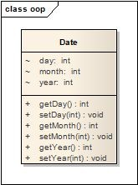

**Encapsulation**

* **Bundling** of **data** with the **methods** that operate on that data (restricting of direct access to some of an object's components)
* Hides the **implementation details** of a class
* Forces the user to use an

**interface** to access data

* Makes the code more

**maintainable**

**UML - Graphical Class Representation**

class name

**Person**

“-” means private access

**-firstName: String**

state

“+” means public access

**+getfirstName(): String**

behaviour

Declaring Constructors

* **Syntax:**

**[<modifier>]<class_name>( <argument>*){**

**<statement>\***

**}**

public class **Date** {

private int year, month, day;

public **Date**( int y, int m, int d) if( verify(y, m, d) ){

year = y; month = m; day = d;

}

}

{

private boolean verify(int y, int m, int d){

//...

}

}

Constructors

* Role: **object initialization**
* **Name** of the constructor must be the same as that of class name.
* Must **not** have **return type**.
* Every class should have **at least one constructor**.
  + If you don't write constructor, compiler will generate the **default constructor**.
* Constructors are usually declared **public**.
  + Constructor can be declared as private → You can't use it outside the class.
* One class can have **more than one constructors.**
  + Constructor *overloading*.

The Default Constructors

* There is always **at least one constructor** in every class.
* If the programmer does not supply any constructors, the

**default constructor** is generated by the compiler

* + The default constructor takes no argument
  + The default constructor's body is empty



public class Date {

private int year, month, day;

**public Date( ){**

**}**

}

**default constructor**

Objects

* Objects are **instances** of classes
* Are **allocated on the heap** by using the new operator
* Constructor is invoked automatically on the new object

Counter c = new Counter();

Date d1 = new Date( 2016, 9, 23); Person p = new Person(“John”,”Smith”);

Packages

* Help manage large software systems
* Contain
  + Classes
  + Sub-packages

**java**

**awt**

Button

Graphics

**lang**

Thread

String

Math

The package statement

* Syntax:

**package <top_pkg_name>[.<sub_pkg_name>]*;**

* Examples:

**package** java.lang;

public class String{

//...

}

* statement **at the beginning** of the source file
* only **one package declaration** per source file
* if **no package name** is declared → the class is placed into the **default package**

The import statement

* Syntax:

**package <top_pkg_name>[.<sub_pkg_name>]*;**

* Usage:

**import <pkg_name>[.<sub_pkg_name>]*.*;**

* Examples:

import java.util.List; import java.io.*;

-precedes all class declarations

-tells the compiler **where to find classes**

Remember

* Class, encapsulation
* Class members:
  + attributes
  + methods
* Object, instance
* Constructor
* Package
* Import statement

Object-oriented programming Types

* Primitive types
* Reference Type
* Parameter Passing
* The **this** reference
* Variables and Scope
* Casting

Java Types

* + **Primitive (8)**
    - Logical: boolean
    - Textual: char
    - Integral: byte, short, int, long
    - Floating: double, float
  + **Reference**
    - All others

Logical - boolean

* Characteristics:
  + Literals:
    - true
    - false
  + Examples:
    - boolean cont = true;
    - boolean exists = false;

Textual - char

* Characteristics:
  + Represents a 16-bit Unicode character
  + Literals are enclosed in single quotes (' ')
  + Examples:
    - 'a' - the letter a
    - '\t' - the TAB character
    - '\u0041' - a specific Unicode character ('A') represented by

4 hexadecimal digits

Integral – byte, short, int, and long

* Characteristics:
  + Use three forms:
    - Decimal: 67

– Octal: 0103 (1x8^2+0x8^1+3x8^0)

* + - Hexadecimal: 0x43
  + Default type of literal is int.
  + Literals with the L or l suffix are of type long.

Integral – byte, short, int, and long

* Ranges:

|  |  |  |
| --- | --- | --- |
| Type | Length | Range |
| byte | 1 byte | -27..27-1 |
| short | 2 byte | -215..215-1 |
| int | 4 byte | -231..231-1 |
| long | 8 byte | -263..263-1 |

Floating Point – float and double

* Characteristics:
* **Size:**
  + float – 4 byte
  + double – 8 byte
* Decimal point
  + 9.65 (double, **default type**)

– 9.65**f** or 9.65**F** (float)

* + 9.65**D** or 9.65**d** (double)
* Exponential notation

– 3.41E20 (double)

Java Reference Types

public class **MyDate** { private int day = 26; private int month = 9; private int year = 2016;

public MyDate( int day, int month, int year){

...

}

}

**MyDate** date1 = new MyDate(20, 6, 2000);

**Constructing and Initializing Objects**

**MyDate** date1 = new MyDate(20, 6, 2000);

Constructing and Initializing Objects

**MyDate** date1 = new MyDate(20, 6, 2000);

**new** MyDate(20, 6, 2000);

1. Memory is allocated for the object
2. Explicit attribute initialization is performed
3. A constructor is executed
4. The **object reference** is returned by the new operator

**Constructing and Initializing Objects**

w operator

5) The reference is assigned to a variable

**new** MyDate(20, 6, 2000);

**MyDate** date1 = new MyDate(20, 6, 2000);

|  |  |
| --- | --- |
| 1. Memory is allocate 2. Explicit attribute in 3. A constructor is ex 4. The **object referen** | d for the object  itialization is performed ecuted  **ce** is returned by the ne |
| date1 = **object ref** | **erence** |

1. **Memory is allocated for the object**

**MyDate** date1 = new MyDate(20, 6, 2000);

**reference**

date1

Implicit initialization

???

|  |
| --- |
| 0 |
| 0 |
| 0 |

**object**

day month year

1. **Explicit Attribute Initialization**

**MyDate** date1 = new MyDate(20, 6, 2000);

**reference**

date1

public class **MyDate**{ private int day = 26; private int month = 9; private int year = 2016;

}

???

|  |
| --- |
| 26 |
| 9 |
| 2016 |

**object**

day month year

**(3) Executing the constructor**

**reference**

date1

**object**

day

month year

public class **MyDate**{ private int day = 26; private int month = 9; private int year = 2016;

}

???

**MyDate** date1 = new MyDate(20, 6, 2000);

|  |
| --- |
| 20 |
| 6 |
| 2000 |

1. **The object reference is returned**

**MyDate** date1 = new MyDate(20, 6, 2000);

**reference**

date1

The address of the object

???

**object**

day month year

0x01a2345

|  |  |
| --- | --- |
| 20 |  |
| 6 |
|  |
| 2000 |

1. **The reference is assigned to a variable**

**MyDate** date1 = new MyDate(20, 6, 2000);

The reference points to the object

0x01a2345

**reference**

0x01a2345

**object**

date1

day month year

|  |
| --- |
| 20 |
| 6 |
| 2000 |

**Assigning References**

* Two variables refer to a single object

date1

date2

0x01a2345

**object**

day

month year

0x01a2345

0x01a2345

**MyDate** date1 = new MyDate(20, 6, 2000);

**MyDate** date2 = date1;

|  |
| --- |
| 20 |
| 6 |
| 2000 |

Parameter Passing Pass-by-Value

public class **PassTest**{

public void changePrimitive(**int** value){

++value;

}

public void changeReference(**MyDate** from, **MyDate** to){ from = to;

}

public void changeObjectDay(**MyDate** date, int day){ date.setDay( day );

}

}

Parameter Passing Pass-by-Value

PassTest pt = new PassTest(); int x = 100; pt.**changePrimitive**( x ); System.out.println( x );

MyDate oneDate = new MyDate(3, 10, 2016); MyDate anotherDate = new MyDate(3, 10, 2001);

pt.**changeReference**( oneDate, anotherDate ); System.out.println( oneDate.getYear() );

pt.**changeObjectDay**( oneDate, 12 ); System.out.println( oneDate.getDay() );

**Output:**

100

2016

12

The this Reference

* Usage:

− To resolve **ambiguity** between *instance variables* and

*parameters*

− To **pass** the current **object as a parameter** to another method

The this Reference

public class **MyDate**{ private int **day** = 26; private int **month** = 9; private int **year** = 2016;

public MyDate( int day, int month, int year){

**this**.**day** = day; **this**.**month** = month; **this**.**year** = year;

}

public MyDate( MyDate date){ **this**.**day** = date.day; **this**.**month** = date.month; **this**.**year** = date.year;

}

public MyDate creteNextDate(int moreDays){ MyDate newDate = new MyDate(**this**);

//... add moreDays return newDate;

}

}

Java Coding Conventions

* Packages
  + ro.sapientia.ms
* Classes
  + SavingsAccount
* Methods
  + getAmount()
* Variables
  + amount
* Constants
  + NUM_CLIENTS

Variables and Scope

* Local variables are
  + Defined **inside a method**
  + Created when the **method is executed** and destroyed when the

**method is exited**

* **Not initialized automatically**
* Created on the **execution stack**

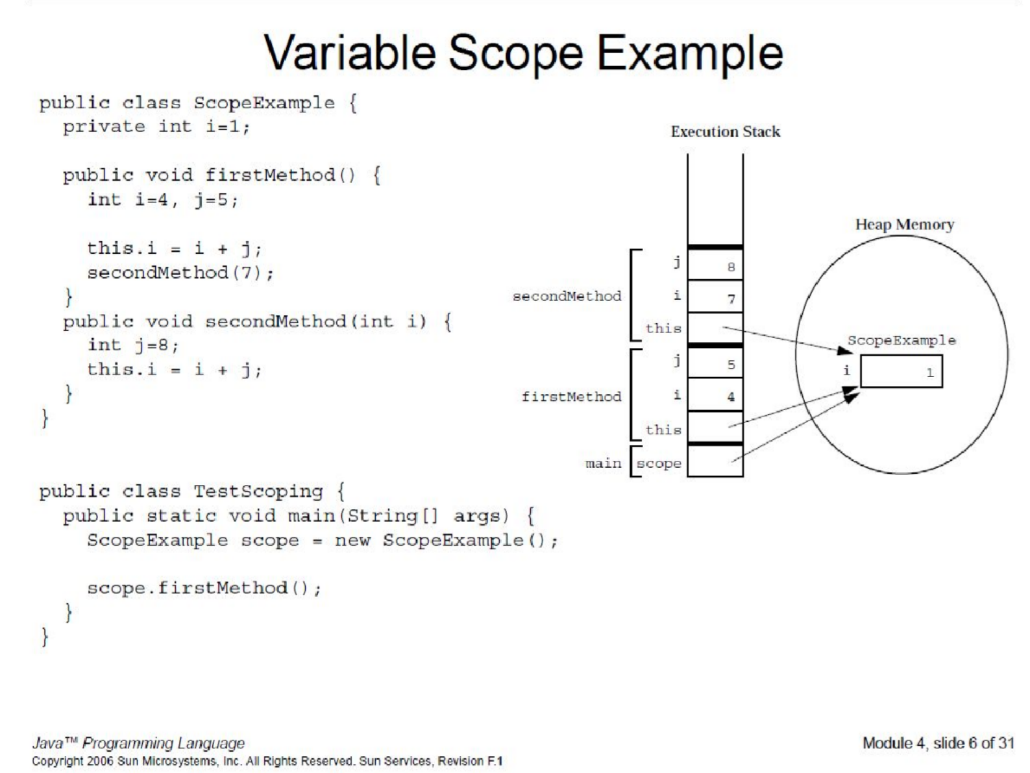

Default Initialization

* Default values for attributes:

|  |  |
| --- | --- |
| **Type** | **Value** |
| **byte** | **0** |
| **short** | **0** |
| **int** | **0** |
| **long** | **0L** |
| **float** | **0.0f** |
| **double** | **0.0d** |
| **char** | **'\u0000'** |
| **boolean** | **false** |
| **refrence** | **null** |

Operators

* Logical operators
* Bitwise operators ( ~, ^, &, |, >>, >>>, << )
* String concatenation ( + )

String Types

* **String**
  + **Immutable –** once created can not be changed
  + Objects are stored in the **Constant String Pool**
* **StringBuffer**
  + **Mutable** – one can change the value of the object
* **Thread-safe**
* **StringBuilder**
  + The same as StringBuffer
* **Not thread-safe**

Object-oriented programming Arrays

* Declaring arrays
* Creating arrays
* Arrays of primitive and reference type
* Initialization of elements
* Multidimensional arrays

Declaring Arrays

* What is an array?

− **Group** of data objects of the **same type**

* Arrays of primitive types:

**int t[];**

**int [] t;**

* Arrays of reference types:

**Point p[];**

**Point[] p;**

Creating Arrays

**Primitive Type**

* Arrays are **objects** → are created with **new**
* Example:

//array **declaration**

int [] t;

//array **creation**

t = new int[10];

//**print** the array – **enhanced for loop**

for**(** int v: t ){ System.out.println( v );

}

Creating Arrays

**Primitive Type**

//array **declaration**

int [] t;

//array **creation**

t = new int[10];

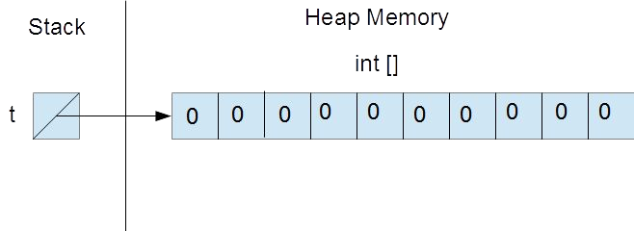

Creating Arrays

**Reference Type**

//array **declaration**

Point [] t;

//array **creation – array of references!!!**

t = new Point[3];

**How many objects of type Point?**

Creating Arrays

**Reference Type**

//array **declaration**

Point [] p;

//array **creation – array of references!!!**

p = new Point[3];

// **Initializing references with objects**

for( int i=0; i<3; ++i){ p[i] = new Point(i, i);

}

**How many objects of type Point?**

Creating Arrays

**Reference Type**

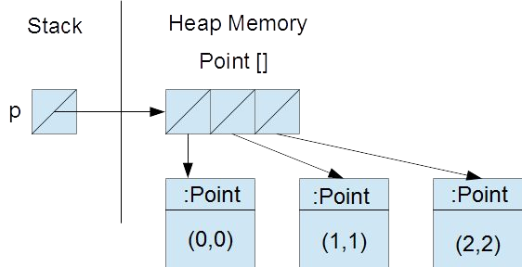

Initializing Arrays

* Create an array with initial values

**String names[] = {“Anna”, “Krisztina”, “Rebekka”}; Point points[] ={ new Point(0,0), new Point(1,1)};**

Array Bounds

**void printElements( int t[] ){**

**for( int i=0; i < t.length; ++i){ System.out.println( t[i] );**

**}**

**}**

Multidimensional Arrays

* **Rectangular** arrays:

**int [][] array = new int[3][4];**

* **Non-rectangular** arrays:

**int [][] array;**

**array = new int[2][]; array[0] = new int[3]; array[1] = new int[5];**

Remember

* Array **declaration** and **creation**
  + Array of primitives
  + Array of references
* Size of an array (public attribute: **length**)
* **Initial values** of array elements

**Module 3 Static Members**

Problems

* How can you create a **constant**?
* How can you declare **data** that is **shared by all instances of a given class**?
* How can you **prevent** a class from being

subclassed?

* How can you **prevent** a method from being

overridden?

Problem

* Create a **Product** class which initializes each new instance with a **serialNumber 1,2, 3,…**

Solution

public class Product{ private int sNumber;

public static int counter = 0;

public Product() { counter++; sNumber = counter;

}

}

**Solution**

Product p1 = new Product(); Product p2 = new Product();

p1

**:Product**

**sNumber: 1**

**Class Product**

**counter: 2**

p2

**:Product**

**sNumber: 2**

**counter: static field sNumber: instance field**

What's wrong?

public class Product{ private int sNumber;

**public static int counter = 0;**

public Product() { counter++; sNumber = counter;

}

}

public class AnyClass{ public void increment() {

**It can be accessed from outside the class!**

**Product.counter++;**

}

}

Better solution

public class Product{ private int sNumber;

**private static int counter = 0;**

**public static int getCounter(){ return counter;**

**}**

public Product() { counter++; sNumber = counter;

}

}

Better solution

public class Product{ private int sNumber;

**private static int counter = 0;**

**public static int getCounter(){ return counter;**

System.out.println( **Product.getCounter()**); Product p = new Product(); System.out.println( **Product.getCounter()**);

**Output?**

**}**

public Product() { counter++; sNumber = counter;

}

}

Accessing static members

Recommended:

**<class name>.<member_name>**

Not recommended (but working):

**<instance_reference>.<member_name>**

System.out.println( **Product.getCounter()**); Product p = new Product(); System.out.println( **p.getCounter()**);

**Output?**

Static Members

* Static data + static methods = static members
* Data are allocated at **class load time** → *can be used without instances*
* Instance methods **may use** static data. **Why?**
* Static methods **cannot use** instance data.

**Why?**

The InstanceCounter class

**public class InstanceCounter { private static int counter;**

**public InstanceCounter(){**

**++counter;**

**}**

**public static int getCounter(){ return counter;**

**Output?**

**}**

**}**

**System.out.println( InstanceCounter.getCounter());**

**InstanceCounter ic = new InstanceCounter(); System.out.println( InstanceCounter.getCounter());**

Singleton Design Pattern

**public class Singleton {**

**private static Singleton instance;**

**private Singleton(){**

**}**

**public static Singleton getInstance(){ if( instance == null ){**

**instance = new Singleton();**

**}**

**return instance;**

**}**

**}**

Static Initializers

public class AClass{

**private static int counter; static {**

// e.g. read counter from a file

**}**

}

The final Keyword

* **Class**
  + You cannot subclass a **final** class.
* **Method**
  + You cannot override a **final** method.
* **Variable**
  + A **final** variable is a constant.
  + You can set a **final** variable only once.
  + Assignment can occur independently of the declaration (*blank final variable*).

Blank Final Variables

**public class Employee{ private final long ID;**

**public Employee(){ ID = createID();**

**}**

**private long createID(){**

**//return the generated ID**

**}**

**…**

**}**

Enumerations

**public enum GestureType { UP,**

**RIGHT, DOWN, LEFT**

**}**

**for(GestureType type: GestureType.*values*()){ System.*out*.println( type );**

**}**

**OUTPUT:**

**UP RIGHT DOWN LEFT**

Enumerations

**public enum GestureType { UP (0, "fel"),**

**RIGHT (1, "jobb"),**

**DOWN (2, "le"),**

**LEFT (3, "bal");**

**GestureType( int value, String name ){ this.value = value;**

**this.name = name;**

**}**

**public int getValue(){ return value;**

**}**

**public String getName(){ return name;**

**}**

**private int value; private String name;**

**}**

**Enumerations**

**Output**

**UP, fel, 0**

**RIGHT, jobb, 1**

**DOWN, le, 2**

**LEFT, bal, 3**

**for(GestureType type: GestureType.values()){ System.out.println(type.name()+", "+**

**type.getName()+", "+ type.getValue());**

**}**

REMEMBER

* **Constant instance data**
* belongs to the **instance**
* **Static data**
  + belongs to the **class**
* **Constant static data**
  + belongs to the **class**

REMEMBER CONSTANT INSTANCE DATA

final

public class Product{

**private final int ID;**

}

REMEMBER STATIC DATA

static

public class Product{ private final int ID; **private static counter;** public Product(){

ID = ++counter;

}

}

REMEMBER CONSTANT STATIC DATA

static final

public class Product{ private final int ID; private static counter;

**private static final String name = “PRODUCT”;**

public Product(){ ID = ++counter;

}

public String getIDStr(){ return name+ID;

}

}

**Module 4 Relationships between classes**

Object-oriented programming Relationships between classes

* 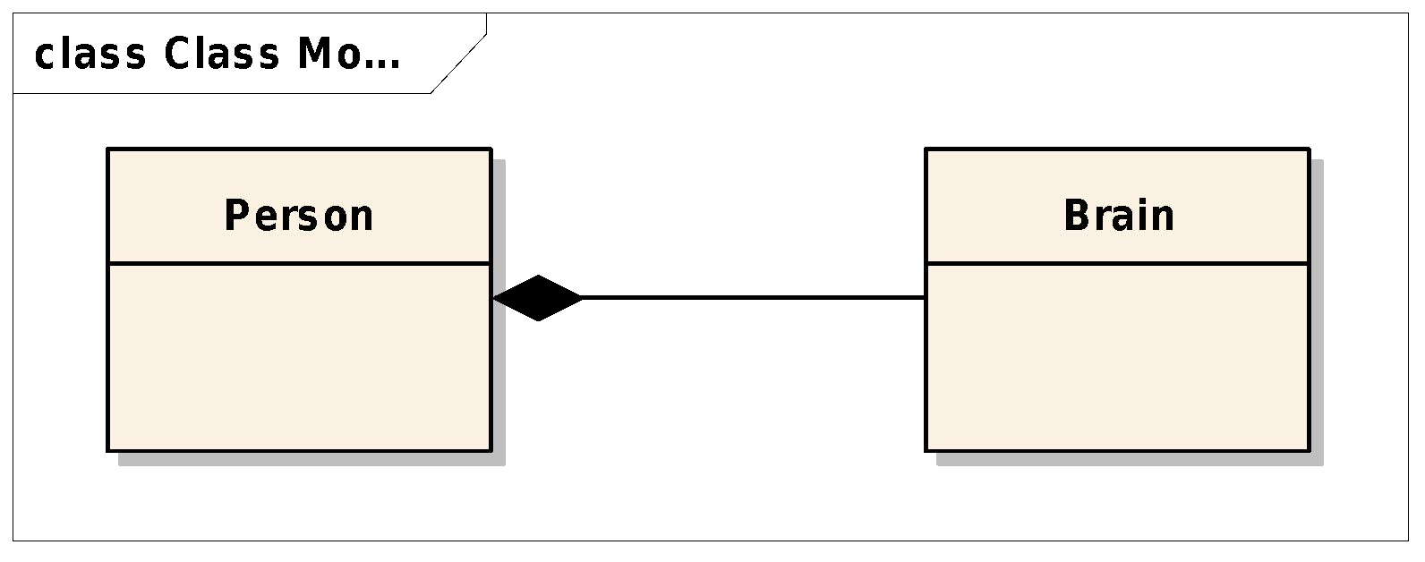**Association** (containment)
  + **Strong** – **Composition**
  + 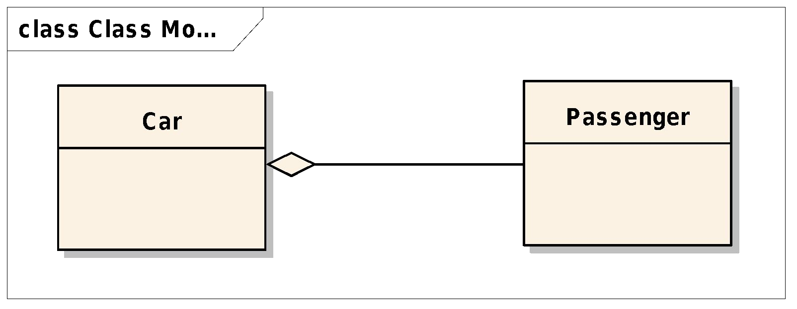**Weak** – **Aggregation**

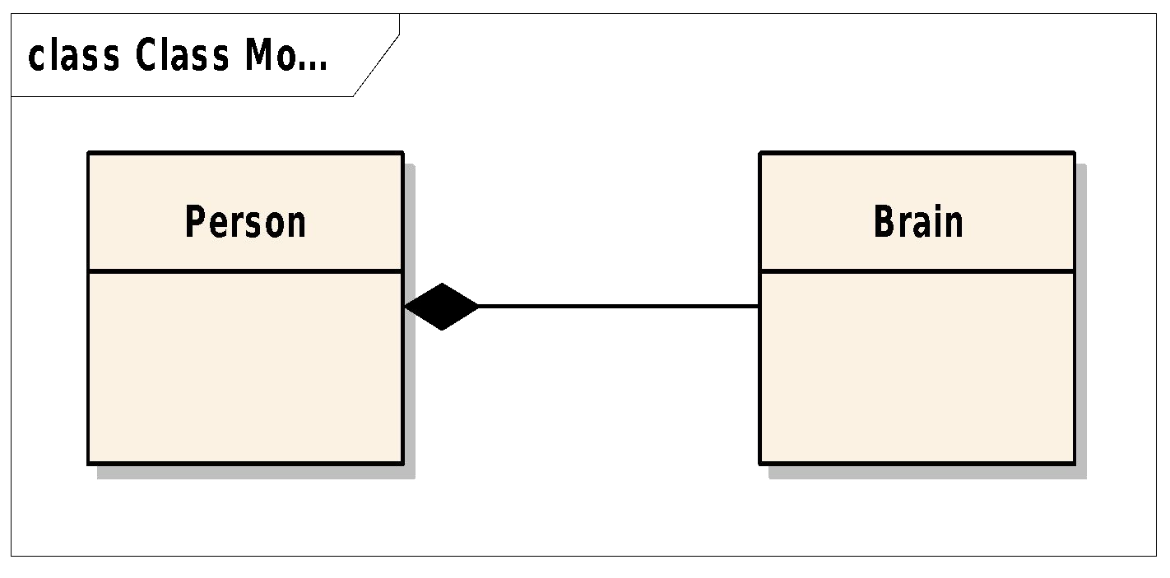Relationships between classes Composition

* Strong type of association
* Full ownership

Relationships between classes Aggregation

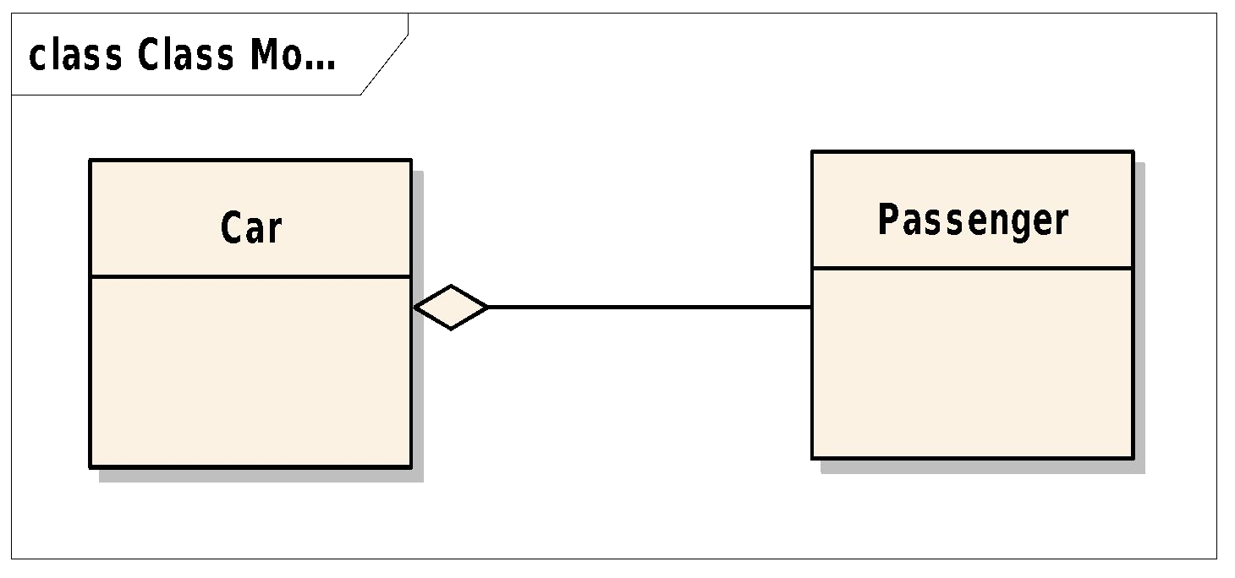

* Weak type of association
* Partial ownership

Relationships between classes Association – Aggregation - Composition



Association

Aggregation

Composition

Relationships between classes Implementing Associations (1)

public class **Brain**{

//...

}

public class **Person**{ private **Brain** brain;

//...

}

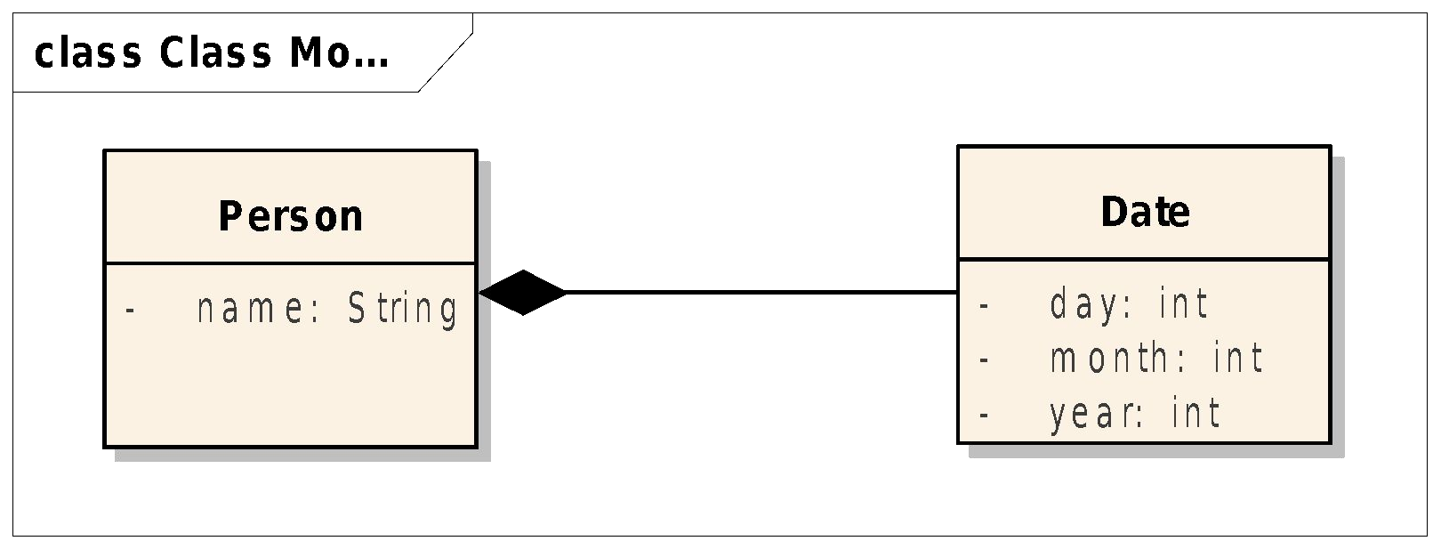

**Relationships between classes Implementing Associations (2)**

public class **Person**{ private String name; private **Date** birthDate;

public Person(String name,

Date birthDate){ this.name = name; this.birthDate = birthDate; }

//...

}

public class **Date**{ private int day; private int month; private int year;

//...

}

Relationships between classes Implementing Associations (3)

Write a program which reads the data of several persons and constructs an array of Persons.

:Date

:Date

Benedek Istvan, 1990, 1, 12

Burjan Maria, 1968, 4, 15

Dobos Hajnalka Evelin, 1986, 3, 17

...

|  |  |
| --- | --- |
| :Person | |
|  | |
|  |  |

|  |  |
| --- | --- |
| :Person | |
|  | |
|  |  |

Relationships between classes Relationship cardinality

* *One-to-one*
* 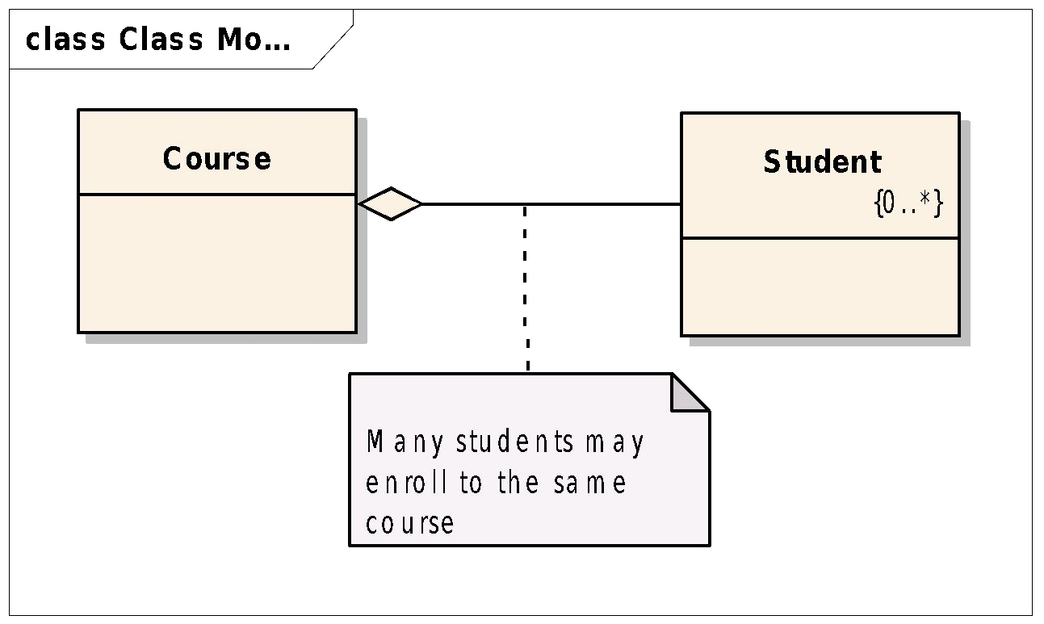*One-to-many*

Relationships between classes Implementing *one-to-many* relationship (1)

public class **Student**{ private **final** long ID; private String firstname; private String lastname;

//...

}

public class **Course**{ private final long ID; private String name;

public static final int MAX_STUDENTS=100; private Student[] **enrolledStudents**; private int **numStudents**;

//...

}

Relationships between classes Implementing *one-to-many* relationship (2)

public class **Course**{ private final long ID; private String name;

public static final int MAX_STUDENTS = 100; private **Student[] enrolledStudents**; private int **numStudents**;

public Course( long ID, String name ){ this.ID = ID;

this.name = name;

**enrolledStudents = new Student[ MAX_STUDENTS ];**

}

public void enrollStudent( Student student ){

**enrolledStudents[ numStudents ] = student;**

**++numStudents;**

}

//...

}

**Relationships between classes Implementing** *one-to-many* **relationship (3)**

public class **Course**{ private final long ID; private String name;

private **ArrayList<Student> enrolledStudents**; public Course( long ID, String name ){

this.ID = ID;

this.name = name;

**enrolledStudents = new ArrayList<Student>();**

}

public void enrollStudent( Student student ){

**enrolledStudents.add(**student**);**

}

//...

}

**Module 5 Inheritance, Polymorphism**

Outline

* Inheritance
  + Parent class
  + Subclass, Child class
* Polymorphism
  + Overriding methods
  + Overloading methods
  + The instanceof operator
  + Heterogeneous collections

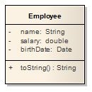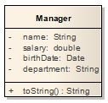

**Problem:** *repetition in implementations*

public class **Manager**{ **private String name; private double salary; private Date birthDate;** private String department;

public String **toString**(){

//...

}

}

public class **Employee**{ **private String name; private double salary; private Date birthDate;**

public String **toString**(){

//...

}

}

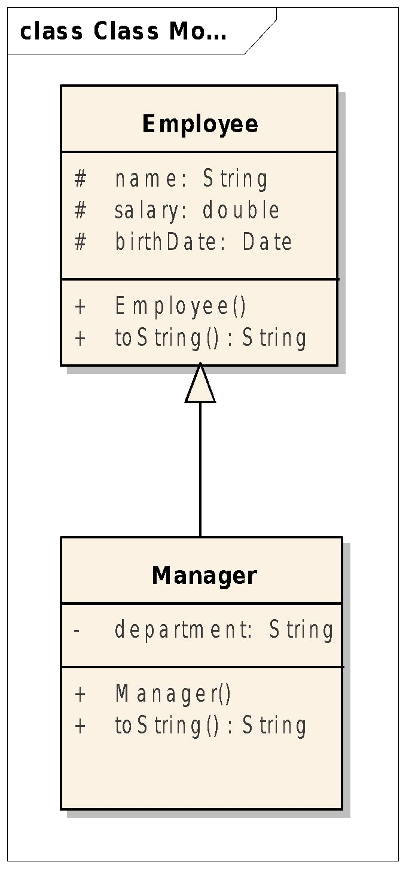**Solution:** *inheritance*

public class **Manager** extends **Employee**{ private String department;

public Manager( … ){

// …

}

public String **toString**(){

// …

}

}

public class **Employee**{ **protected** String name; **protected** double salary; **protected** Date birthDate; public **Employee**( … ){

// …

}

public String **toString**(){

//...

}

}

Inheritance - syntax

**<modifier> class <name> extends <superclass>{**

**<declaration*>**

**}**

public

class **Manager extends Employee**{

}

The subclass

* **Inherits** the **data** and **methods** of the

parent class

* **Does not inherit the constructors** of the

parent class

* Opportunities:
  1. add new data
  2. add new methods
  3. override inherited methods (polymorphism)

The subclass

* Opportunities:

1. add new data → **department**
2. add new methods → e.g. **getDepartment()**
3. override inherited methods → **toString()**

Invoking Parent Class Constructors

public class **Employee**{ **protected** String name; **protected** double salary; **protected** Date birthDate;

public **Employee**( String name, double salary, Date birthDate){ this.name = name;

this.salary = salary; this.birthDate = birthDate;

}

//...

}

public class **Manager** extends **Employee**{ private String department;

public **Manager**( String name, double salary, Date birthDate,

String department){

**super(name, salary, bityhDate);**

this.department = department;

}

//...

}

Access Control

|  |  |  |  |  |
| --- | --- | --- | --- | --- |
| Modifier | Same | Same | Subclass | Universe |
|  | Class | Package |  |  |
| **private**  default! | Yes Yes | Yes |  | |
| **protected** | Yes | Yes | Yes | |
| **public** | Yes | Yes | Yes Yes | |

Polymorphism - Overriding Methods

* A subclass can modify the **behavior**

inherited from a parent class

* A subclass can create a method with different functionality than the parent's method but with the:
* same **name**
* same **argument list**
* almost the same **return type**

(can be a subclass of the overriden return type)

Overriding Methods

public class **Employee**{ **protected** String name; **protected** double salary; **protected** Date birthDate; public **Employee**( … ){

// …

}

**public String toString(){**

**return “Name: “+name+” Salary: ”+salary+” B. Date:”+birthDate;**

**}**

}

public class **Manager** extends **Employee**{ private String department;

public **Manager**( … ){

// …

}

**@Override**

**public String toString(){**

**return “Name: “+name+” Salary: ”+salary+” B. Date:”+birthDate**

**+” department: ”+department;**

**}**

}

Invoking Overridden Methods

public class **Employee**{ **protected** String name; **protected** double salary; **protected** Date birthDate; public **Employee**( … ){

// …

}

public String **toString()**{

return “Name: “+name+” Salary: ”+salary+” B. Date:”+birthDate;

**}**

}

public class **Manager** extends **Employee**{ private String department;

public **Manager**( … ){

// …

}

public String **toString()**{

return **super.toString()** + ” department: ”+department;

}

}

Overridden Methods Cannot Be Less Accessible

public class **Parent**{ **public** void **foo**(){}

}

public class **Child** extends **Parent**{ **private** void **foo**(){} **//illegal**

}

Overriding Methods

* *Polymorphism:* the ability to have many different forms

Employee e = new Employee(...); System.out.println( **e.toString()** );

e = new Manager(...); **//Correct**

System.out.println( **e.toString()** );

Which toString() is invoked?

Polymorphic Arguments

**Liskov Substitution!**

|  |  |
| --- | --- |
| public String **createMessage**( **Employee e** ){ return “Hello, ”+**e.getName()**;  }  //...  Employee e1 = new Employee(“Endre”,2000,new Date(20,8, 1986)); Manager m1 = new Manager(“Johann”,3000,  new Date(15, 9, 1990),”Sales”);  //...  System.out.println( **createMessage**( **e1** ) ); | |
| System.out.println( **createMessage**( **m1** | ) ); |

Heterogeneous Arrays

Employee emps[] = new Employee[ 100 ]; emps[ 0 ] = **new Employee();**

emps[ 1 ] = **new Manager();**

emps[ 2 ] = **new Employee();**

// …

**// print employees**

for( Employee e: emps ){ System.out.println( **e.toString()** );

}

**// count managers**

int counter = 0;

for( Employee e: emps ){

if( e **instanceof** Manager ){

++counter;

}

}

Static vs. Dynamic type of a reference

// static (compile time) type is: **Employee**

Employee e;

// dynamic (run time) type is: **Employee**

e = new Employee();

// dynamic (run time) type is: **Manager**

e = new Manager();

Static vs. Dynamic type of a reference

Employee e = new Manager(“Johann”,3000,

new Date(10,9,1980),”sales”); System.out.println( **e.getDepartment()** );**// ERROR**

//**Solution**

System.out.println( ((Manager) e)**.getDepartment()** );**// CORRECT**

//**Better Solution**

if( e **instanceof** Manager ){

System.out.println( ((Manager) e)**.getDepartment()** );

}

The instanceof Operator

**Animal** a = new **Bear**();

//expressions

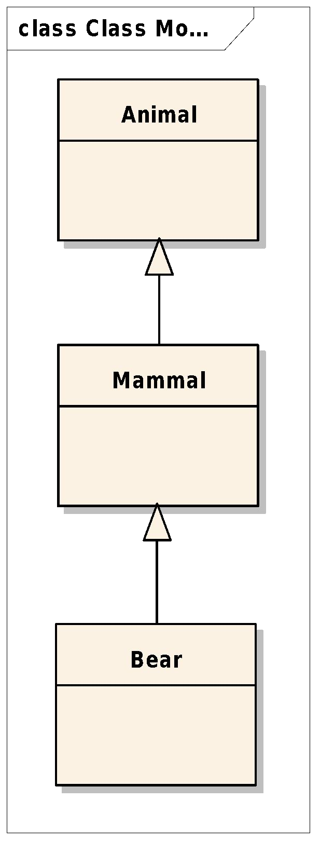

|  |  |  |  |
| --- | --- | --- | --- |
| a | **instanceof** | Animal | → true |
| a | **instanceof** | Mammal | → true |
| a | **instanceof** | Bear → | true |
| a | **instanceof** | Date → | false |

Polymorphism Overloading Methods

* + **Polymorphism:** *the ability to have many different forms*
  + Methods overloading:
    - methods having the **same name**,
    - argument list **must** differ,
    - return types **can be** different.
  + Example:

public void **println**(int i) public void **println**(float f) public void **println**(String s)

**Polymorphism Overloading Constructors**

public class **Employee**{ **protected** String name; **protected** double salary; **protected** Date birthDate;

public **Employee**( String name, double salary, Date birthDate){ this.name = name;

this.salary = salary; this.birthDate = birthDate;

}

public **Employee**( String name, double salary){

**this(name, salary, null);**

}

public **Employee**( String name, Date birthDate){

**this(name, 1000, birthDate);**

}

//...

}

Polymorphism

*The ability to have many different forms*

* + Methods **overloading**
* **same name**, *different signature*
* e.g. a class having multiple constructor
* **compile-time** polymorphism (**static polymorphism**)
  + Methods **overriding**
* **same name**, *same signature*
* e.g. toString()
* **run-time** polymorphism (**dynamic polymorphism**)

Remember

* Inheritance

– Subclass opportunities

* Polymorphism
  + *Overriding* methods
  + *Overloading* methods
  + *Polymorphic* argument
  + *Heterogeneous* collections
* Static vs. dynamic type
* The instanceof operator

Inheritance and Polymorphism

**Methods Common to All Objects**

* + The equals method
  + The toString method
  + The clone method

Inheritance and Polymorphism

**Methods Common to All Objects**

* + **Object** is a concrete class with non final methods:

− equals

− toString

− clone, …

* **It is designed for extension!**
* Its methods have explicit *general contracts*

The equals method

**In class Object equals tests object identity**

**MyDate s1 = new MyDate(20, 10, 2016); MyDate s2 = new MyDate(20, 10, 2016); System.out.println( s1.equals(s2)); s1 = s2;**

**System.out.println( s1.equals(s2));**

**Output?**

An equals example

public class MyDate { private int day; private int month; private int year;

**public boolean equals(Object o) {**

boolean result = false;

if ( (o != null) && (**o instanceof MyDate**) ) { MyDate d = (MyDate) o;

if ((day == d.day) && (month == d.month) && (year == d.year)) {

result = true;

}

}

return result;

**}**

}

Another equals example

public class MyDate { private int day; private int month; private int year;

**@Override**

**public boolean equals(Object o) {**

if (this == o) return true;

if (o == null || **this.getClass() != o.getClass()**) return false; MyDate myDate = (MyDate) o;

return day == myDate.day && month == myDate.month && year == myDate.year;

**}**

}

The equals method

**In class MyDate equals tests object logical equality**

**MyDate s1 = new MyDate(20, 10, 2016); MyDate s2 = new MyDate(20, 10, 2016); System.out.println( s1.equals(s2)); s1 = s2;**

**System.out.println( s1.equals(s2));**

**Output?**

The equals method implements an equivalence relation

* **Reflexive**
  1. equals(x):**true**
* **Symmetric**
  1. equals(y):**true ↔** y.equals(x):**true**
* **Transitive**

1. equals(y):**true and** y.equals(z):**true** → x.equals(z):**true**

The toString method

* Characteristics:
  + Converts an object to a String
  + Override this method to provide information about a user-defined object in **readable format**

Wrapper Classes

|  |  |
| --- | --- |
| **Primitive Type** | **Wrapper Class** |
| boolean | Boolean |
| byte | Byte |
| char | Character |
| short | Short |
| int | Integer |
| long | Long |
| float | Float |
| double | Double |

Wrapper Classes

**Boxing and Unboxing**

**int i = 420;**

**Integer anInt = i; // boxing - creates new Integer(i); int j = anInt; // unboxing - calls anInt.intValue();**

**Wrapper Classes**

**Warning! Performance loss!**

**public static void main(String[] args) { Long** sum = 0L;

for (long i = 0; i < Integer.MAX_VALUE; i++) { sum += i;

}

System.out.println(sum);

}

**Too slow!!!**

**Module 6**

**Interfaces and Abstract Classes**

Outline

* Interfaces
* Interfaces (since Java 8)
* Abstract classes
* Sorting
  + **Comparable** interface
  + **Comparator** interface

Interfaces

* Properties
  + Define **types**
  + Declare a **set of methods** (*no implementation!*)

– ADT – Abstract Data Type

* + Will be **implemented** by classes

The Driveable Interface

public interface **Driveable**{

|  |  |  |
| --- | --- | --- |
| public | void | start(); |
| public | void | forward(); |
| public | void | turn( double angle); |
| public | void | stop(); |

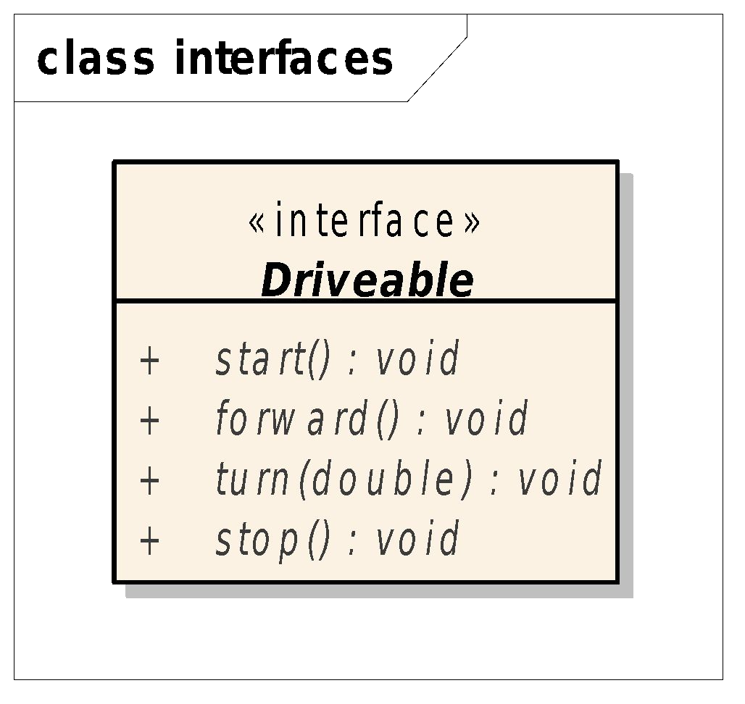}

Implementing Interfaces

public class Bicycle **implements** Driveable{ @Override

public void start() {

System.out.println("The bicycle has been started");

}

@Override

public void forward() {

System.out.println("The bicycle moves forward");

}

@Override

public void turn( double angle) { System.out.println("The bicycle turns "+angle+

" clockwise");

}

@Override

public void stop() {

System.out.println("The bicycle has been stopped");

}

}

Implementing the Driveable Interface

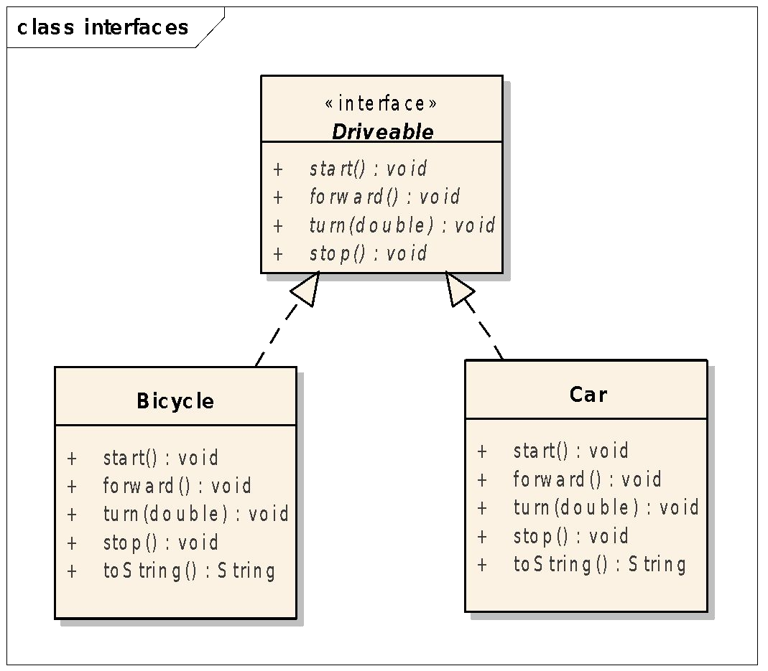

Interfaces

* The interface contains **method declarations**

and may contain constants

* All the methods are **public** (even if the modifier is missing)
* Interfaces are **pure abstract classes** → cannot be instantiated
* The implementer classes should **implement all the methods** declared in the interface
* A **class** can **extend a single class** but may

**implement any number of interfaces**

Iterator interface

**List<String>** l1 = new **ArrayList<>**(); l1.add(“Welcome”);

l1.add(“to“);

l1.add(“Java”);

Iterator<String> it = l1.iterator(); while( it.hasNext() ){

System.out.print( it.next() + “ “);

}

for(String str: l1){ System.out.print( str + “ “);

}

Q & A

Select the correct statements!

1. Driveable a;
2. Driveable a = new Driveable();
3. Driveable t[] = new Driveable[ 3 ];
4. public void drive( Driveable d );

Interfaces vs. Classes

* 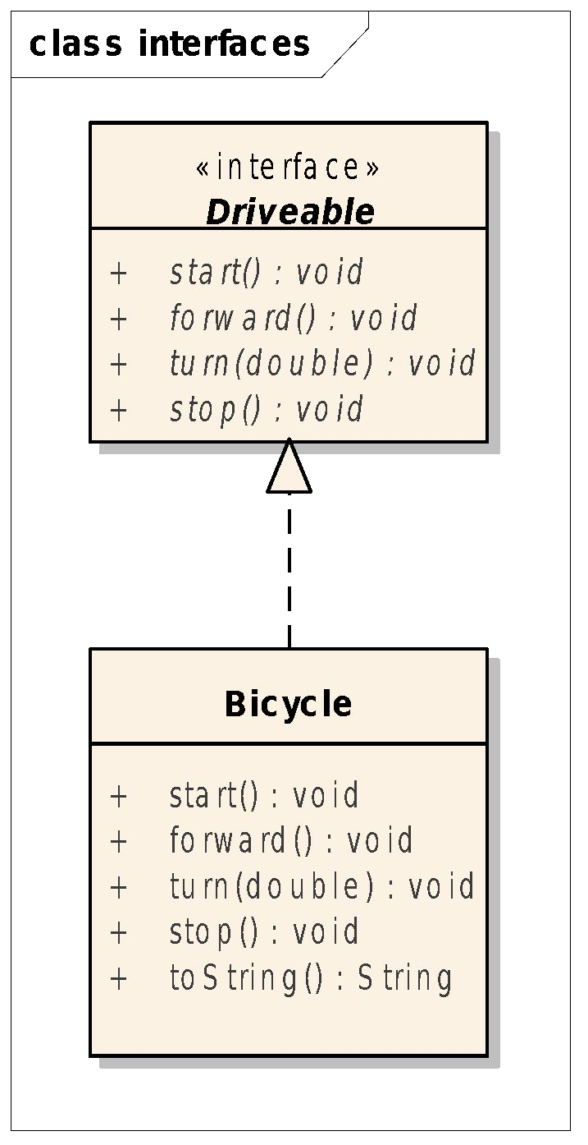**Interface:**
  + User-defined type
  + Set of methods
  + No implementations provided
  + Cannot be instantiated
* **Class:**
  + User-defined type
  + Set of data and methods
  + All the methods are implemented
  + Can be instantiated

**Polymorphic Argument**

public class Utils{

public **static** void moveMe(**Driveable** v){ v.start();

for( int i=0; i<12; ++i){ v.turn(15);

}

v.stop();

What am I doing?

}

}

Utils.moveMe( **new Bicycle()** ); Utils.moveMe( **new Car()** );

Polymorphic Argument

public class Utils{

public **static** void **printIt**(**List<String>** list){ for( String s: list ){

LinkedList<T>

<<interface>> List<T>

System.out.println( s );

}

ArrayList<T>

}

}

**ArrayList<String>** l1 = new **ArrayList<>**();

// add elements to l1 Utils.**printIt(l1)**;

**LinkedList<String>** l2 = new **LinkedList<>**();

// add elements to l2 Utils.**printIt(l2)**;

Interfaces Java 8

* Java Interface **Default** Method
* Java Interface **Static** method

Java Interface **Default** Method

public **interface** Animal{

// Abstract method

void eat();

// Implemented method

**default** void log( String str ){ System.out.println(

“Animal log: “+str);

}

}

Java Interface **Default** Method

public class **Bear** implements **Animal**{

**// Mandatory!!!**

void eat(){ System.out.println(“Bear eats”);

}

// It is **not mandatory** to provide

// implementation for the **log** method

}

Java Interface **Static** Method

public interface MatrixOperations{

**static Matrix add(Matrix a, Matrix b){**

**//...**

**}**

}

Java Interface **Static** Method

public interface MatrixOperations{

**static Matrix add(Matrix a, Matrix b){**

**//...**

**}**

}

Java Interface **Static** Method

public interface MatrixOperations{

**static Matrix add(Matrix a, Matrix b){**

**//...**

**}**

}

**Helper methods** – associated with class, not instances

**Cannot be overriden** in implementer classes

Abstract Classes

* May contain **abstract** and **implemented methods** as well
* May contain **data**
* Cannot be instantiated
* Are designed for subclassing

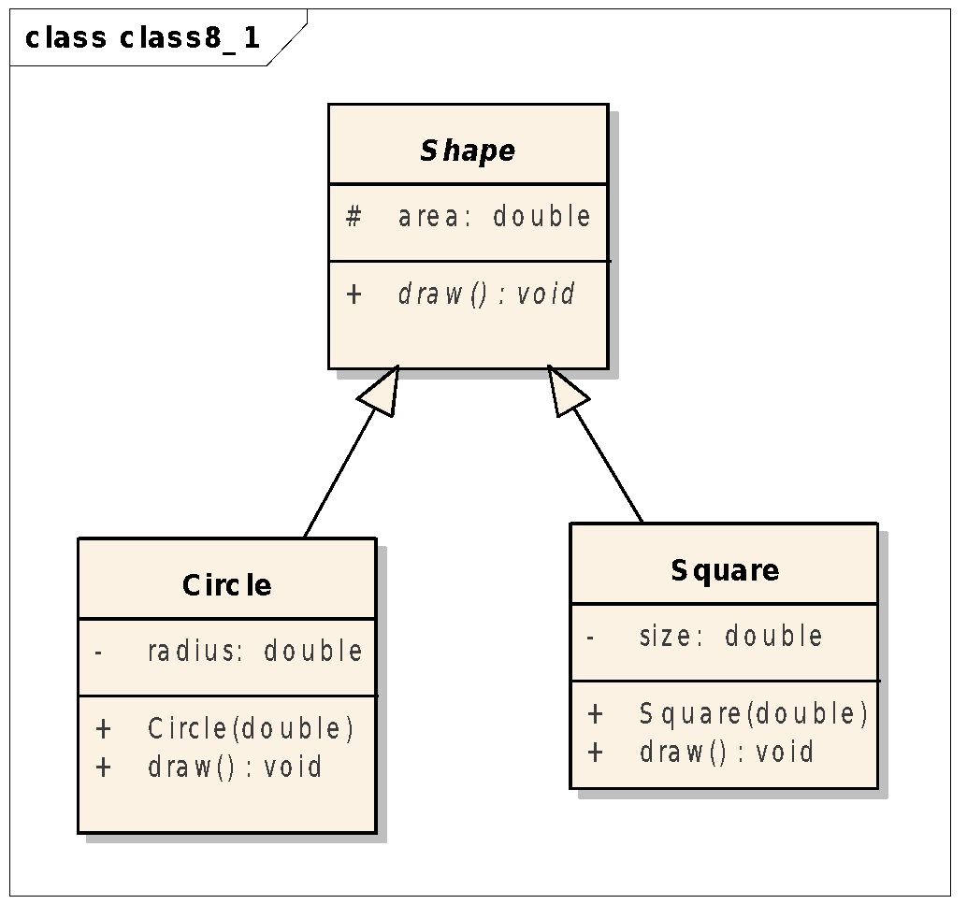

**Abstract Classes**

**Abstract Classes**

public class Square extends Shape{ private double size;

public Square( double size ){ this.size = size; this.area = size * size;

}

@Override

public void draw() { System.out.println("I am a square");

}

}

public **abstract** class Shape { protected double area; public **abstract** void draw();

}

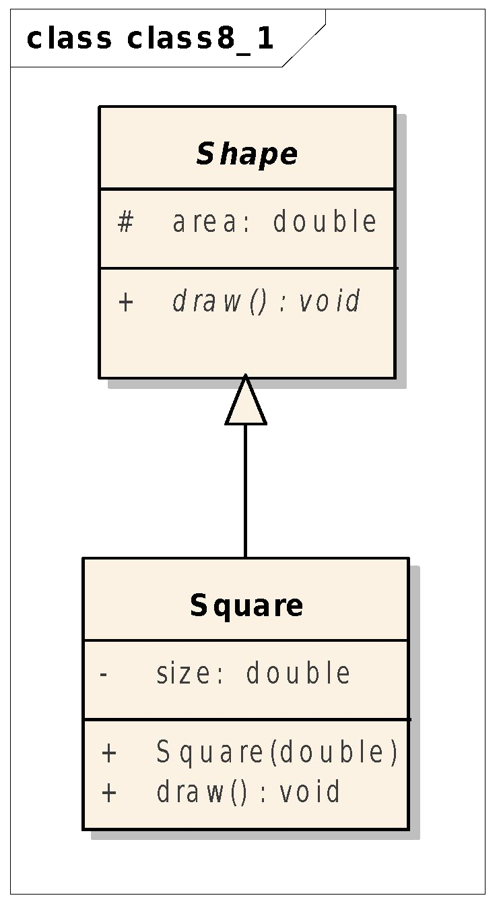

**Abstract Classes vs. Classes**

* **Abstract class:**
  + User-defined type
  + Set of data and methods
  + Abstract and implemented methods

**– Cannot be instantiated**

– Designed to be subclassed

* **Class:**
  + User-defined type
  + Set of data and methods
  + All the methods are implemented

**– Can be instantiated**

**Abstract Classes vs. Classes vs. Interfaces**

|  |  |  |  |
| --- | --- | --- | --- |
|  | Interface | Abstract class | Class |
| Abstract method | Yes | Yes | No |
| Implemented method | No Yes(since Java 8) | Yes | Yes |
| Attribute | No | Yes | Yes |
| Constants (final) | Yes | Yes | Yes |

Sorting and Interfaces

* Sorting Strings, primitives
  + Arrays.sort()
  + Collections.sort()
* Sort **user-defined** types
  + The Comparable interface
  + The Comparator interface

Sorting Collections

* Sorting objects by their **natural order**
  + The **Comparable** interface
* Sorting object using a Comparator
  + The **Comparator** interface

The Comparable interface

**interface Comparable {**

**int compareTo(Object o);**

**}**

* 1. compareTo(y): 0: x equal to y positive: x > y; negative: x< y;

The Comparable<T> interface

**interface Comparable<T> { int compareTo(T o);**

**}**

Attempts to use a different type are caught at compile time!!!

The Comparable<T> interface

**public class Point implements Comparable<Point>{**

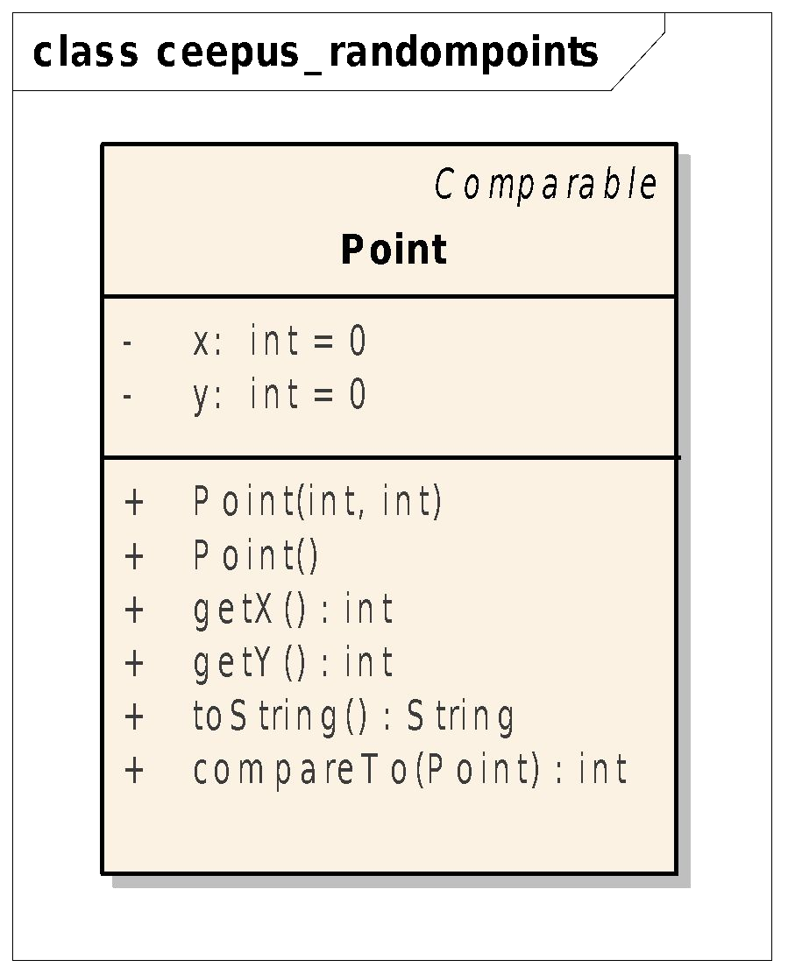**//... @Override**

**public int compareTo(Point o) {**

**if( o == null ) throw new NullPointerException(); if (this.x == o.x && this.y == o.y) {**

**return 0;**

**}**

**if( this.x == o.x){**

**return Integer.compare(this.y, o.y);**

**}**

**return Integer.compare(this.x, o.x);**

**}**

**}**

The Comparable<T> interface Consistency

**If a class overrides the equals method, then it is**

advisable (*but not enforced*) that

**a.equals(b)**

exactly when

**a.compareTo(b) == 0**

The Comparator<T> interface

***What if we need multiple sorting criteria?***

* Class **Point**
  + Sorting by x then by y
  + Sorting by y then by x
  + Sorting by the distance from the origin (0,0)
* For each class we can define **only one natural ordering** through the

**Comparable** interface

* We can define an **unlimited number of ordering** using the

**Comparator** interface

The Comparator<T> interface

**interface Comparator<T> *{***

**int compare (T x, T y);**

**}**

The Comparator<T> interface (1)

**class DistanceComparator implements Comparator<Point>{ private final static Point origo = new Point(0,0);**

**@Override**

**public int compare(Point p1, Point p2) { return Double.compare(**

**p1.distanceTo(origo), p2.distanceTo(origo));**

**}**

**}**

**ArrayList<Point> points = new ArrayList<Point>(); points.add( new Point(1,2));**

**points.add( new Point(2,2));**

**points.add( new Point(1,3));**

**Collections.sort( points, new DistanceComparator() ); for( Point point: points ){**

**System.out.println(point);**

**}**

The Comparator<T> interface (2)

**Anonymous inner class**

ArrayList<Point> points = new ArrayList<>(); points.add(new Point(1, 2));

points.add(new Point(2, 2));

points.add(new Point(1, 3));

Collections.*sort*( points, **new Comparator<Point>(){ private final Point origo = new Point(0,0);**

**@Override**

**public int compare(Point p1, Point p2) {**

**return Double.compare(**

**p1.distanceTo(origo), p2.distanceTo(origo));**

**}**

**}**);

for( Point point: points){ System.*out*.println( point );

}

**The Comparator<T> interface (3)**

**Lambda**

ArrayList<Point> points = new ArrayList<>(); points.add(new Point(1, 2));

points.add(new Point(2, 2));

points.add(new Point(1, 3));

Collections. *sort***(**points,

**(Point p1, Point p2) ->**

**{**

**final Point origo = new Point(0,0);**

**return Double.compare(p1.distanceTo(origo),**

**p2.distanceTo(origo));**

**}**

**)**;

for (Point point : points) { System.*out*.println(point);

}

**Module 7 Exceptions**

Exceptions

* Define exceptions
* Exception handling: try, catch, and

finally

* Throw exceptions: throw, throws
* Exception categories
* User-defined exceptions

**Exception Example**

public class **AddArguments** {

public static void main(String[] args) { int sum = 0;

for( String arg: args ){

sum += **Integer.parseInt( arg )**;

}

System.out.println( "Sum: "+sum );

}

}

**java AddArguments 1 2 3**

Sum: 6

**java AddArguments 1 foo 2 3**

**Exception in thread "main" java.lang.NumberFormatException: For input string: "foo"**

**at java.lang.NumberFormatException.forInputString(NumberFormatException.java:65) at java.lang.Integer.parseInt(Integer.java:580)**

**at java.lang.Integer.parseInt(Integer.java:615)**

**at addarguments.AddArguments.main(AddArguments.java:**line_number**) Java Result: 1**

The try-catch statement

public class **AddArguments2** {

public static void main(String[] args) {

**try{**

int sum = 0;

for( String arg: args ){

sum += **Integer.parseInt( arg )**;

}

System.out.println( "Sum: "+sum );

**} catch( NumberFormatException e ){**

System.err.println(“Non-numeric argument”);

**}**

}

}

**java AddArguments2 1 foo 2 3**

Non-numeric argument

**The try-catch statement**

public class **AddArguments3** {

public static void main(String[] args) { int sum = 0;

for( String arg: args ){

**try{**

sum += **Integer.parseInt( arg )**;

**} catch( NumberFormatException e ){**

System.err.println(arg+”is not an integer”);

**}**

}

System.out.println( "Sum: "+sum );

}

}

**java AddArguments3 1 foo 2 3**

foo is not an integer Sum: 6

The try-catch statement

**try{**

// critical code block

// code that might throw exceptions

**} catch( MyException1 e1 ){**

// code to execute if a MyException1 is thrown

**} catch( MyException2 e2 ){**

// code to execute if a MyException2 is thrown

**} catch ( Exception e3 ){**

// code to execute if any other exception is thrown

**} finally{**

// code always executed

**}**

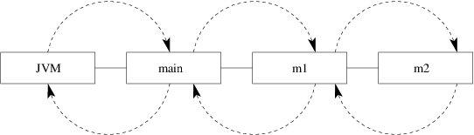

**Call Stack Mechanism**

* If an exception is not handled in a method, it is thrown to the caller of that method
* If the exception gets back to the main method and is not handled there, the program is terminated abnormally.

Closing resources

**The finally clause (1)**

**try{**

connectDB(); doTheWork();

**} catch( AnyException e ){**

logProblem( e );

**} finally {**

disconnectDB();

**}**

The code in the **finally** block is always executed (even in case of return statement)

Closing resources

**The finally clause (2)**

static String readFirstLineFromFile(String path)

throws IOException { BufferedReader br = new BufferedReader(

new FileReader(path));

**try {**

return br.readLine();

**} finally {**

br.close();

**}**

}

Closing resources

**The try-with-resources Statement**

* The try-with-resources statement ensures that each resource is closed at the end of the statement.

static String readFirstLineFromFile(String path)

throws IOException {

**try (BufferedReader br =**

**new BufferedReader(new FileReader(path)))** { return br.readLine();

}

}

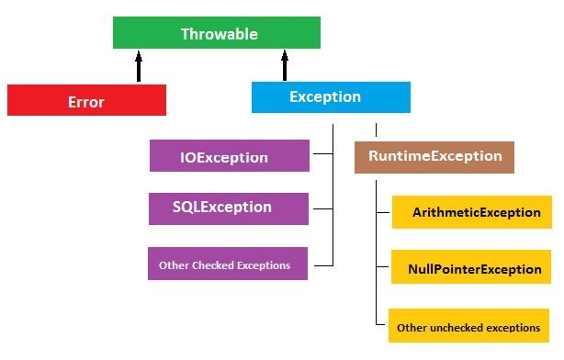

**Exception Categories**

* **Checked** and **unchecked** exceptions

**The Handle or Declare Rule**

public static int countLines( String filename ){ int counter = 0;

**try** (**Scanner scanner = new Scanner(new File(filename))**)**{**

while (scanner.hasNextLine()) { scanner.nextLine();

++counter;

}

**}catch**( **FileNotFoundException** e)**{**

e.printStackTrace();

**HANDLE**

**}**

return counter;

}

**Usage:**

**System.out.println(ClassName.countLines(“input.txt”));**

The Handle or Declare Rule

public static int countLines(String filename) throws

FileNotFoundException {

**try** (**Scanner scanner = new Scanner(new File(filename))**) **{**

int counter = 0;

while (scanner.hasNextLine()) { scanner.nextLine();

++counter;

**DECLARE**

**throws**

}

return counter;

**}**

}

**Usage:**

**try{**

**System.out.println(ClassName.countLines(“input.txt”));**

**} catch( FileNotFoundException e ){ e.printStackTrace();**

**}**

The throws Clause

void trouble1 () **throws Exception1** {...}

void trouble2 () **throws Exception1, Exception2** {...}

Principles:

* You do not need to declare runtime (unchecked) exceptions
* You can choose to handle runtime exceptions (e.g.

**IndexArrayOutOfBounds, NullPointerException**)

Creating Your Own Exceptions

The overriding method can throw:

* No exceptions
* One or more of the exceptions thrown by the overridden method
* One or more subclasses of the exceptions thrown by the overridden method

The overridden method cannot throw:

* Additional exceptions not thrown by the overridden method
* Superclasses of the exceptions thrown by the overridden method

User-Defined Exception

public class **StackException** extends **Exception** { public StackException(String message) {

super( message );

}

}

User-Defined Exception

public class Stack {

private Object elements[]; private int capacity; private int size;

public Stack( int capacity ){ this.capacity = capacity; elements = new Object[ capacity ];

}

public void push(Object o) **throws StackException** { if (size == capacity) {

throw new StackException("Stack is full");

}

elements[size++] = o;

}

public Object top() **throws StackException** { if (size == 0) {

throw new StackException("Stack is empty");

}

return elements[size - 1];

}

// ...

}

User-Defined Exception

Stack s = new Stack(**3**);

for (int i = 0; i < **10**; ++i) { try {

s.push(i);

} catch (**StackException** ex) { ex.printStackTrace();

}

}

Best practices to handle exceptions

* Clean up resources in a **finally** block or use a

**try-with-resource** statement

* Prefer specific exceptions
* Don't ignore exceptions
* Don't log and throw. Instead, wrap the exception without consuming it
* Catch early, handle late Source: 9 Best Practices to Handle Exceptions in Java

**Module 8 Nested Classes**

Nested Classes

* **When?**
  + If a class is used only inside of another class (encapsulation)
  + Helper classes

Nested Classes

* **The place of nesting**
  + Class
  + Method
  + Instruction
* **Embedding method**
  + Static
  + Non-static

**public class Slist{**

Static Nested Class

**private Element head;**

**public void insertFirst( Object value ){ head = new Element(value, head);**

**}**

**private static class Element{ private Object value; private Element next;**

**public Element( Object value, Element next){ this.value = value;**

**this.next = next;**

Used only inside the **Slist** class

**}**

**public Element( Object value){ this.value = value; this.next = null;**

**}**

**}**

**}**

The Iterator interface

**Package: java.util**

**public interface Iterator{ public boolean hasNext(); public Object next();**

**//optional**

**public void remove();**

**}**

Make Slist iterable using the Iterator interface!!!

The Iterator interface

**Slist list = new Slist(); for( int i=0; i<10; ++i ){**

**list.insertFirst( i );**

**}**

**Iterator it = list.createIterator(); while( it.hasNext() ){**

**System.out.println( it.next() );**

Factory Method Design Pattern

**}**

* + 1. **Solution – Non-static Nested Class**

**public class Slist{ private Element head;**

**//...**

**public Iterator createIterator(){ return new ListIterator();**

**}**

**private class ListIterator implements Iterator{ private Element act = head;**

**public boolean hasNext(){ return act != null;**

**}**

**public Object next(){**

**Object value = act.value; act = act.next;**

**return value;**

Relation between Slist and ListIterator objects

**}**

**}**

**}**

1. **Solution – Non-static Nested Class**

**public class Slist{ private Element head;**

**//...**

**public Iterator createIterator(){ return new ListIterator();**

Class ListIterator is used

only once!!!

**}**

**private class ListIterator implements Iterator{ private Element act = head;**

**public boolean hasNext(){ return act != null;**

**}**

**public Object next(){**

**Object value = act.value; act = act.next;**

**return value;**

**}**

**}**

**}**

1. **Solution – Anonymous Inner Class**

**public class Slist{ private Element head;**

**//...**

**public Iterator createIterator(){ return new Iterator(){**

**private Element act = head;**

**public boolean hasNext(){ return act != null;**

**}**

**public Object next(){**

**Object value = act.value; act = act.next;**

**return value;**

**}**

**};**

**}**

**Module 9 Threads**

Outline

* Definition
* **Creation:** *Thread* **and** *Runnable*
* Synchronization
* Executors and thread pools

What are threads?

* **Operating Systems**
* lightweight process
* runs in the address space of a process
* has its own program counter (PC)+stack
* shares code and data with other threads
* **Object-oriented Programming**

- an object – an instance of the class Thread

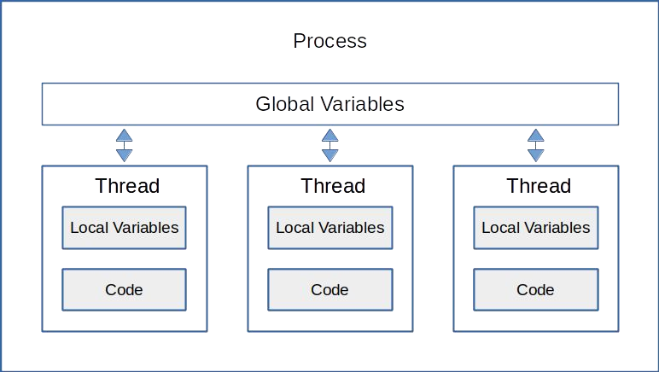

**What are threads?**

Threads

**java.lang.Thread** = **Infrastructure(PC+Stack)**

**java.lang.Runnable = Code**

Thread's creation (1)

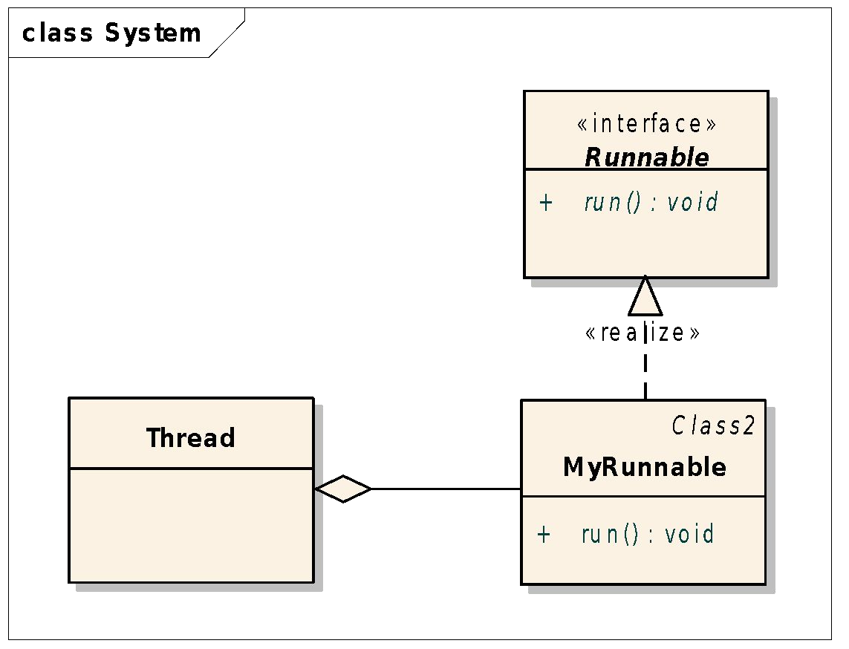

public class **MyRunnable** implements **Runnable**{ private int id;

public MyRunnable(int id ){ this.id = id;

}

public void run(){

for( int i=0; i<10; ++i){ System.out.println(“Hello”+id+” “+i);

}

}

}

…

MyRunnable r = new MyRunnable(1); Thread t = new Thread( r );

Starting the thread

**Thread t = new Thread( r );**

Constructor initializes the thread object

**t.start();**

Calls the thread object's run method

Thread's creation (1)

public class Test{

public static void main(String args[]){

Thread t1 = new Thread( new MyRunnable(1)); Thread t2 = new Thread( new MyRunnable(2)); t1.start();

t2.start();

}

}

Output?

Thread's creation (2)

class MyThread extends **Thread** { private int id;

public MyThread(int id) { this.id = id;

}

@Override

public void run() {

for (int i = 0; i < 10; ++i) { System.out.println("Hello" + id + " " + i);

}

}

}

…

Thread t = new MyThread(1); t.start();

Thread's creation (2)

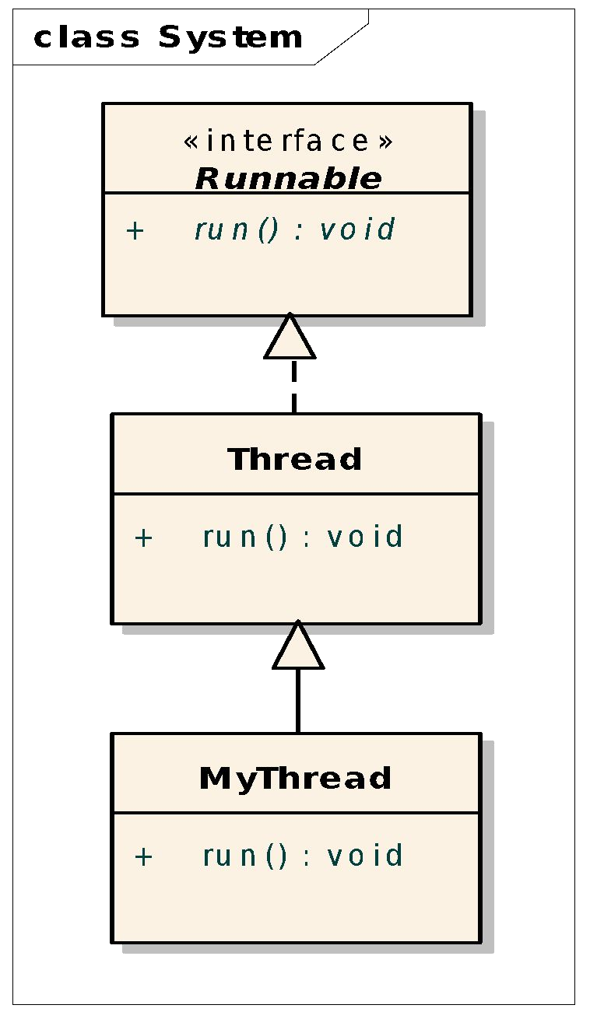

public class Test {

public static void main(String[] args) { Thread t1 = new MyThread(1);

Thread t2 = new MyThread(2); t1.start();

t2.start();

}

}

Example (1)

public class **MyFirstRunnable** implements **Runnable**{ @Override

public void run() { System.out.println("In a thread");

}

}

**Usage:**

Thread thread = new Thread(new MyFirstRunnable()); thread.start();

System.out.println("In the main Thread");

Output?

Example (2)

public class **MyFirstRunnable** implements **Runnable**{ @Override

public void run() { System.out.println("In a thread");

}

}

**Usage:**

Runnable runnable = new **MyFirstRunnable()**; for(int i = 0; i<25; i++){

new Thread(runnable).start();

}

How many threads?

Example (3)

public class **MyFirstRunnable** implements **Runnable**{ @Override

public void run() { System.out.println("In a thread");

}

}

**Usage:**

Thread thread = new Thread(new MyFirstRunnable()); thread.**run()**;

System.out.println("In the main Thread");

Output?

Operations on threads

* make the current Thread **sleep**
* wait for another thread to complete (**join**)
* manage the **priorities** of threads
* **interrupt** a thread

sleep()

try { Thread.**sleep**(1000);

} catch (InterruptedException e){ e.printStackTrace();

}

sleep()

try { Thread.**sleep**(1000);

} catch (InterruptedException e){ e.printStackTrace();

}

* It always pause the current thread execution.
* The actual time thread sleeps depends on system timers and schedulers (for a busy system, the **actual time** for sleep is a little bit **more than** the specified **sleep time**).

join()

Thread **t2** = new Thread(new R());

**t2**.start(); try {

**t2**.**join()**;

} catch (InterruptedException e){ e.printStackTrace();

}

setPriority()/getPriority()

public class ThreadPriorityRange {

public static void main(String[] args) { System.out.println("Minimal priority : " +

Thread.MIN_PRIORITY);

System.out.println("Maximal priority : " +

Thread.MAX_PRIORITY);

System.out.println("Norm priority : " +

Thread.NORM_PRIORITY);

}

}

interrupt()

A thread can be interrupted:

* **if the thread is sleeping**
* **if the thread is waiting for another thread to join**

interrupt()

private static class **ForeverRunnable** implements Runnable { public void run() {

while (true) { System.out.println(Thread.currentThread().getName() +

": " + System.currentTimeMillis());

try { Thread.sleep(5000);

} catch (InterruptedException e) { System.out.println(

Thread.currentThread().getName() +

"has been interrupted");

}

}

}

}

interrupt()

private static class **ForeverRunnable** implements Runnable { public void run() {

while (true) { System.out.println(Thread.currentThread().getName() +

": " + System.currentTimeMillis());

try { Thread.sleep(5000);

} catch (InterruptedException e) {

System.out.println( Thread.currentThread().getName() +

"has been interrupted");

}

}

}

}

public static void main(String[] args) {

Thread t2 = new Thread(new **ForeverRunnable**()); System.out.println("Current time millis : " +

System.currentTimeMillis());

t2.start(); t2.**interrupt()**;

}

Thread's states

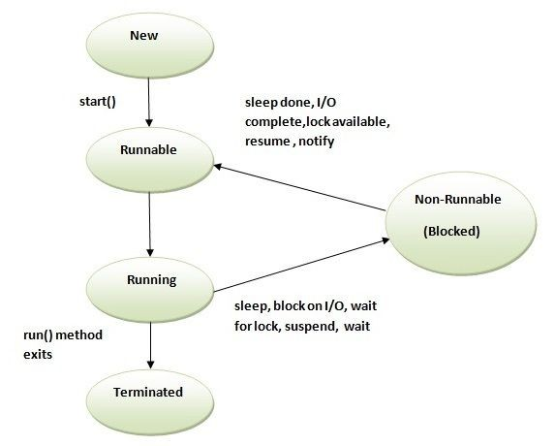

Need for synchronization

public class **Counter** { private int value = 0;

public int **getNextValue()**{ return value++;

}

}

**Thread1**

|  |  |  |
| --- | --- | --- |
| **Need for synchronization**  **Thread1**  public class **Counter** { private int value = 0;  public int **getNextValue()**{ return value++;  }  } | | |
|  | **Thread2** |  |

Need for synchronization

class **Counter** { private int value;

public int getNextValue() { return ++value;

}

public int getValue(){ return value;

}

}

Need for synchronization

Runnable **task** = new Runnable() { @Override

public void run() {

for( int i=0; i<**10000**; ++i) { counter.getNextValue();

}

}

};

Need for synchronization

Counter counter = new Counter(); Thread t1 = new Thread(**task**); Thread t2 = new Thread(**task**); t1.start();

t2.start(); try{

t1.join();

t2.join();

} catch( InterruptedException e ){

}

System.out.println("COUNTER: "

Output?

+counter.getValue());

Need for synchronization

value++ <--- Not atomic!

1. Read the current value of "value"
2. Add one to the current value
3. Write that new value to "value"

Solution (1)

public class **Counter** { private int value = 0;

public **synchronized** int **getNextValue()**{ return value++;

}

}

Solution (2)

public class **Counter** { private int value = 0;

public int **getNextValue()**{ **synchronized**(this){

value++;

}

return value;

}

}

Solution (3)

import java.util.concurrent.atomic.**AtomicInteger**;

public class Counter {

private **AtomicInteger value = new AtomicInteger(0);**

public int getNextValue(){

return value.incrementAndGet();

}

public int getValue(){ return value.intValue();

}

}

Synchronized Blocks

* + every object contains a single **lock**
  + the **lock** is taken when synchronized section is entered
  + if the **lock** is not available, thread enters a waiting queue
  + if the **lock** is returned, thread is resumed

Thread Safe

* A class is **thread safe** if it behaves always in the same manner when accessed from multiple threads.
* Stateless objects (**immutable classes**) are always thread safe:
  + String
  + Long
  + Double

# Executors and thread pools

**CPU cores**

Linux:

CPU info

$cat /proc/cpuinfo

CPU cores info

$top

then press **1**

# Thread pool

* + In **Java threads** are mapped to

**system-level threads** (Operating system resources)

* + When you use a thread pool, write your concurrent code in the form of parallel tasks and submit them for execution to an instance of a thread pool.

[https://www.baeldung.com/thread-pool-java-and-guava](http://www.baeldung.com/thread-pool-java-and-guava)

# Thread Pool

**ExecutorService**

// number of increments int n = 10000;

Counter counter = new Counter();

**ExecutorService executor = Executors.*newFixedThreadPool*(2);**

Runnable task = new Runnable() { @Override

public void run() {

for( int i=0; i<n; ++i) { counter.getNextValue();

}

}

};

**executor.execute( task ); executor.execute( task );** executor.shutdown();

try {

executor.awaitTermination(Long. *MAX_VALUE*, TimeUnit. *NANOSECONDS*);

} catch (InterruptedException e) { e.printStackTrace();

}

System.*out*.println("Counter: " + counter.getValue());

**Module 10 GUI Programming Swing and JavaFx**

Java GUIs

* **AWT (Abstract Windowing Toolkit) –** since JDK 1.0
  + Uses native control
  + Appearance/behavior depends on platform
* **Swing –** since JDK 1.2
  + Implemented completely in Java (light weight)
* **JavaFX –** since JDK 8
  + Written as a native library
  + Provided on a wide variety of devices
* **SWT (Standard Widget Toolkit)**
  + Eclipse

# GUI Programming Swing

Outline

* ***Containers, components* and *layout managers***
* FlowLayout, BorderLayout, and GridLayout
* Add components to a container
* Events and event handling
* Delegation model
* Adapter classes

Component

* Represents an object with *visual* representation
* Other names for components: widgets, controls



JLabel

JMenuItem

JButton

Container

* A special component that holds other components
* Used for grouping other components

JPanel

contains a picture

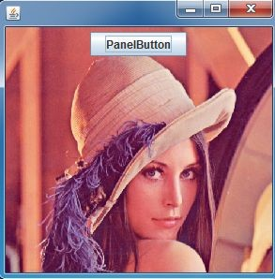

JFrame

The first GUI program

public static void main(String[] args) {

**JFrame** f = new **JFrame**("The First Swing

Application"); f.setDefaultCloseOperation(JFrame.EXIT_ON_CLOSE); f.**setBounds**( 100,100, 300, 300); f.**setVisible**(true);

}

Frames

**JFrame**

* Top level container
  + can have menu bars
* Contains a JRootPane
* Have title and resizing corners
* Have BorderLayout as

the default layout manager

Menu Bar Frame

Content Pane



Positioning Components

* Responsibility of the layout manager
  + **size** (dimension: width and height in pixels)
  + **position** (location of the top left corner)
* You can disable the layout manager: setLayout(null),

then use

* setSize() + setLocation()
* setBounds()

Organizing Components (1)

JFrame f = new JFrame("The First Swing Application"); f.setDefaultCloseOperation(JFrame.EXIT_ON_CLOSE);

**JPanel p = new JPanel(); p.setBackground(Color.blue); JButton b = new JButton("Yes"); p.add(b);**

**f.setContentPane(p);**

f.setBounds( 100,100, 300, 300); f.setVisible(true);

Organizing Components (2)

JFrame f = new JFrame("The First Swing Application"); f.setDefaultCloseOperation(JFrame.EXIT_ON_CLOSE);

**JPanel p = new JPanel(); p.setBackground(Color.blue); p.setLayout( null );**

**JButton b = new Jbutton("Yes"); b.setSize(100,60); b.setLocation(200, 200); p.add(b);**

**f.setContentPane(p);**

f.setBounds( 100,100, 300, 300); f.setVisible(true);

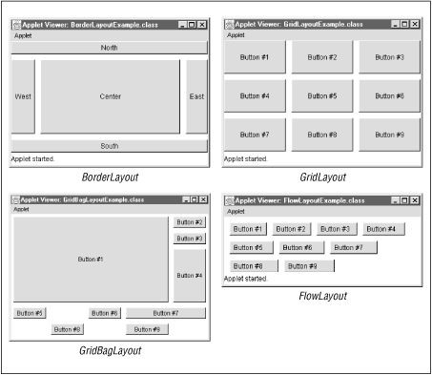

**Layout Managers**

* FlowLayout
* BorderLayout
* GridLayout
* GridBagLayout

Layout Managers

GridLayout

public static JPanel createPanel( int n){ JPanel panel = new JPanel(); panel.setLayout(new **GridLayout( n, n)**); for( int i=0; i<n; ++i){

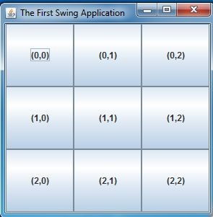for( int j=0; j<n; ++j){ panel.add( new JButton

("("+i+","+j+")"));

}

}

return panel;

}

Creating UI

* Aggregation

– FrameAggregation

* Inheritance

– FrameInheritance

Creating UI

**Aggregation**

**public class FrameAggregation {**

**private static void initFrame() {**

**JFrame frame = new JFrame("FrameAggregation"); frame.add(new JButton("Ok"), "Center"); frame.setDefaultCloseOperation(JFrame.EXIT_ON_CLOSE); frame.setBounds(100, 100, 200, 200); frame.setVisible(true);**

**}**

**public static void main(String[] args) { initFrame();**

**}**

**}**

Creating UI

**Inheritance**

**public class FrameInheritance extends JFrame { private JButton button;**

**public FrameInheritance(){ initComponents();**

**}**

**private void initComponents() { this.setTitle("FrameInheritance");**

**this.add(new JButton("Ok"), "Center"); this.setDefaultCloseOperation(JFrame.EXIT_ON_CLOSE); this.setBounds(100, 100, 200, 200); this.setVisible(true);**

**}**

**public static void main(String[] args) { new FrameInheritance();**

**}**

**}**

Menus

**private static JMenuBar createMenu() {**

***//Menubar***

**MenuBar menuBar; JMenu filemenu, helpmenu; JMenuItem menuItem;**

**menuBar = new JMenuBar();**

***// Build File menu.***

**filemenu = new JMenu("File"); menuBar.add(filemenu); menuItem = new JMenuItem("New"); filemenu.add(menuItem); menuItem = new JMenuItem("Exit"); filemenu.add(menuItem);**

***// Build Help menu.***

**helpmenu = new JMenu("Help"); menuBar.add(helpmenu);**

**menuItem = new JMenuItem("About"); helpmenu.add(menuItem);**

**return menuBar;**

**}**

**frame.setJMenuBar(*createMenu*());**

Dialogs

**JOptionPane (1)**

**JOptionPane.showMessageDialog(**

**Component parent, String message);**

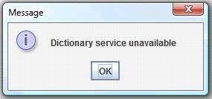

Dialogs

**JOptionPane (2)**

**int result =**

**JOptionPane.showConfirmDialog(**

**Component parent, String message);**

**Result:**

**YES_OPTION (0), NO_OPTION (1), CANCEL_OPTION (2)**

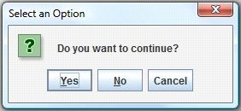

Dialogs

**JOptionPane (3)**

**String value=**

**JOptionPane.showInputDialog("Please input a value");**

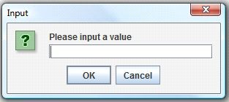

Dialogs

**JOptionPane (4)**

**String options[]={"Apple", "Grape", "Strawberry"};**

**int res = JOptionPane.*showOptionDialog*(form, "Choose an option", "OptionDialog",JOptionPane.*DEFAULT_OPTION*, JOptionPane.*WARNING_MESSAGE*,null, options, options[0]);**

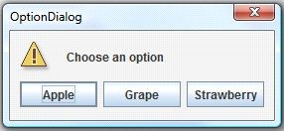

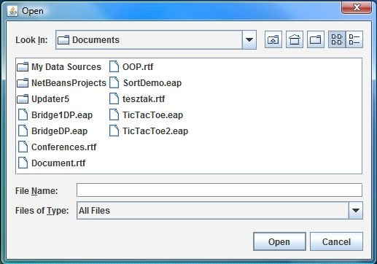

**Dialogs**

**Chooser**

**JFileChooser chooser = new JFileChooser();**

**int returnVal = chooser.showOpenDialog(parent); if(returnVal == JFileChooser.*APPROVE_OPTION*) {**

**System.*out*.println(**

**"You chose to open this file: " + chooser.getSelectedFile().getName());**

**}**

Borders

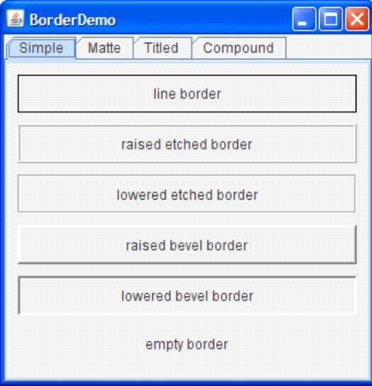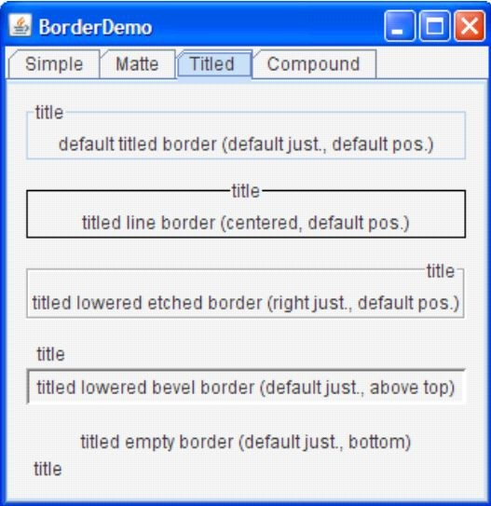

JPanel pane = new JPanel(); pane.setBorder(BorderFactory.createLineBorder(Color.black));

<http://docs.oracle.com/javase/tutorial/uiswing/components/border.htm> l

Custom properties

* (key, value) pairs associated to **JComponent**

type objects

* Key: **Object**
* Value: **Object**

JButton button = new JButton("Press Me"); button.**putClientProperty**("order","10");

//...

button.**getClientProperty**("order");

Event Handling

* **Event** – objects that describe what happened
* **Event source** – the generator of an event
* **Event handler** – a method that
  + receives an event object,
  + deciphers it,
  + and processes the user's interaction

The user clicks on the button

Event Handler

Panel

Button

nEvent

Actio

Frame

actionPerformed( ActionEvent e){

...

}

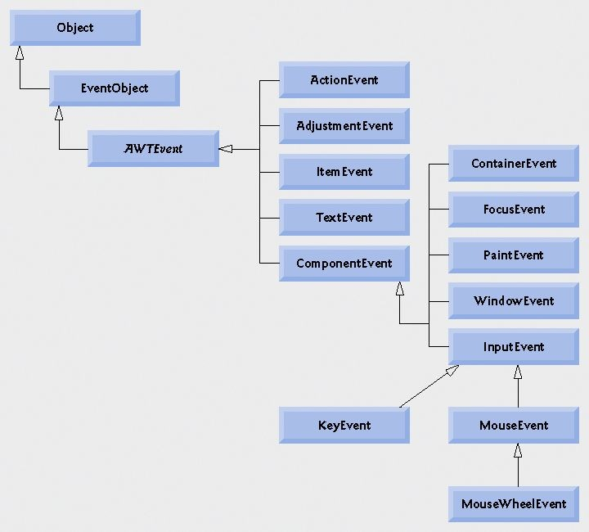

Event Types

* Low level
  + Window
  + Keyboard
  + Mouse
* High level
  + ActionEvent
  + ItemEvent

●

`

|  |  |  |
| --- | --- | --- |
| **Event Handling**  The user clicks on the button   * *One event –* many *handlers* Frame   Panel   * Event handlers are registered Button **ActionEvent**   by event source components  Event Handler1 actionPerformed( **ActionEvent** e){  ...  }  Event Handler2 | | |
|  | actionPerformed( **ActionEvent** e){  ...  } |  |

Delegation Model

* Client objects (handlers) register with a GUI component that they want to observe
* GUI components trigger the handlers for the type of event that has occurred
* Components can trigger more than one type of events

Delegation Model

Event handler

JButton b = new JButton("Yes"); f.add( b );

b.**addActionListener**( new **ActionListener**()**{ @Override**

**public void actionPerformed(ActionEvent e) { if( b.getText().equals("Yes")){**

Event source

**b.setText("No");**

**}else{**

**b.setText("Yes");**

**}**

**}**

**}**);

1. Definition of an **anonymous inner class**

which implements ActionListener interface

1. Creation of an instance from that anonymous inner class
2. This instance is responsible for event handling

Delegation Model Java 8 - Lambdas

JButton b = new JButton("Yes"); f.add( b ); b.addActionListener(**e->**

ActionEvent

**{**

**b.setText( b.getText().equals("No") ? "Yes": "No");**

**}**

);

Many sources – One listener

**public class MyFrame implements Ac**`**tionListener{**

**// ...**

**public void initComponents(){ for( int i=0; i<n; ++i){**

**for( int j=0; j<n; ++j){**

**JButton b = new JButton(""); panel.add( b); b.addActionListener( this );**

**}**

**}**

**}**

**@Override**

**public void actionPerformed(ActionEvent e) { JButton source = (JButton) e.getSource(); source.setBackground(Color.red);**

**}**

**}**

Example

**Custom Component**

public class DrawComponent extends JComponent{

private ArrayList<Point> points= new ArrayList<Point>(); private Color color = Color.red;

public DrawComponent(){ this.addMouseListener(new MouseAdapter(){

@Override

public void mousePressed(MouseEvent e) { points.clear();

points.add( new Point( e.getX(), e.getY()));

}

});

this.addMouseMotionListener(new MouseMotionAdapter(){ @Override

public void mouseDragged(MouseEvent e) { points.add( new Point( e.getX(), e.getY())); DrawComponent.this.repaint();

}

});

}

…

}

Example

**Custom Component**

public class DrawComponent extends JComponent{

//... @Override

public void paint(Graphics g) { g.setColor(color);

if( points != null && points.size()>0){ Point startPoint = points.get(0); for( int i=1; i<points.size(); ++i ){

Point endPoint = points.get(i); g.drawLine(startPoint.x, startPoint.y,

endPoint.x, endPoint.y); startPoint = endPoint;

}

}

}

public void clear(){ points.clear(); repaint();

}

}

Event listeners

* **General listeners**
  + ComponentListener
  + FocusListener
  + MouseListener
* **Special listeners**
  + WindowListener
  + ActionListener
  + ItemListener

`

Event adapter classes

* Problem:
  + Sometimes you need only one event handler method, but the listener interface contains several ones
  + You have to implement all methods, most of them with empty ones
* Solution:
  + An Event Adapter is a convenience class
  + Implements all methods of a listener interface with empty methods
  + You extend the adapter class and override that specific method

Event Adapter Classes Example

public class MyClass extends JFrame **{**

...

someObject.**addMouseListener(** new **MouseAdapter**() **{**

public void mouseClicked(MouseEvent e) {

*//Event listener implementation*

}

**})**;

**}**

# GUI Programming JavaFX

Sources:

* + - https://docs.oracle.com/javafx/2/events/jfxpub-events.htm
    - <http://tutorials.jenkov.com/javafx>
    - [https://www.tutorialspoint.com/javafx](http://www.tutorialspoint.com/javafx)

Outline

* Creating UI
  + Declarative UI - FXML
  + Programmatic - Java
* Event Handling

Cross-platform

JavaFX can run on:

* Windows
* Linux
* Mac
* iOS
* Android

GUI components

|  |  |  |
| --- | --- | --- |
| **Core** | **Layout Panes (Containers)** | **Basic Controls** |
| Stage, Scene, Node, Properties, FXML | HBox, VBox, BorderPane, StackPane GridPane, FlowPane, TilePane,  ... | Label, Button, TextField, ListView, DatePicker, FileChooser, ... |
| **Web** | **Other concepts** |  |
| WebView, WebEngine | Font, Canvas, Animation, Video, ... |  |

JavaFX overview

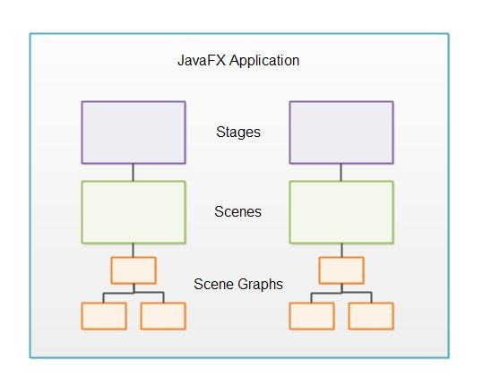

Stage vs Scene

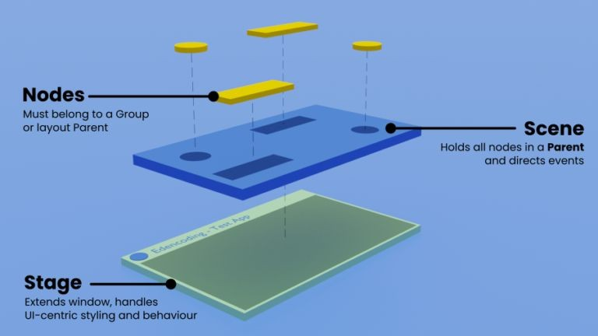

source

Stage

* outer frame (window)
* primary Stage object

created by the JavaFX runtime

Scene

* a stage can only show one scene at a time
* you can exchange scenes at runtime

Scene Graph

* Controls must be attached to scenes
* Components attached are called **nodes**
  + branch nodes (parent nodes)
  + leaf nodes

Your first JavaFX application

public class Main extends Application {

**@Override**

public void **start**(**Stage** primaryStage) throws Exception{ Parent root =

FXMLLoader.*load*(getClass().getResource("sample.fxml")); primaryStage.setTitle("First App"); primaryStage.setScene(new **Scene**(root, 300, 275)); primaryStage.show();

}

public static void main(String[] args) {

*launch*(args);

}

}

JavaFX UI

1. Declarative UI - FXML
2. Programmatic UI - Java
3. **Declarative UI**

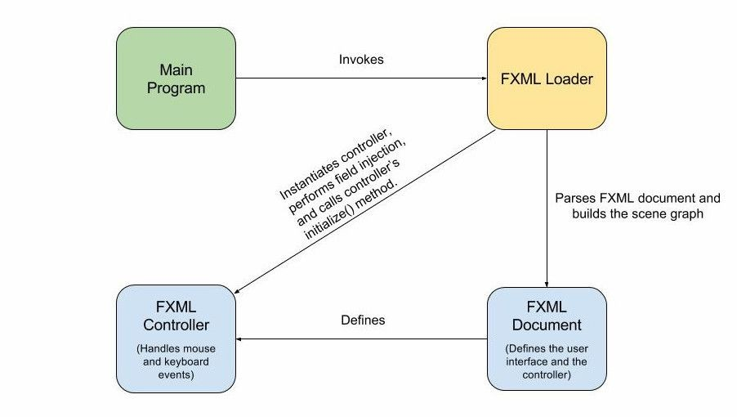

**2.**

**3.**

**1.**

FXML - Adding UI elements

* top-level element (**layout**)
* children (controls)

**<VBox>**

<children>

**<Label/>**

**<TextField/>**

**<Button/>**

</children>

**</VBox>**

FXMLLoader

@Override

public void start(Stage primaryStage) throws Exception{ **Parent root** = **FXMLLoader.*load*(getClass().getResource("sample.fxml"));** primaryStage.setTitle("Hello World"); primaryStage.setScene(new Scene(**root**, 300, 275)); primaryStage.show();

}

FXML - Control properties

<TextField

fx:id="inputText" prefWidth="100.0" />

<Button

fx:id="okBtn" alignment="CENTER_RIGHT" **onAction**="#**refresh**" text="OK" textAlignment="CENTER" />

FXML - Event handling

<TextField



public class Controller {

public void **refresh**(**ActionEvent** e){ Button button = (Button)e.getSource();

// ...

}

}

fx:id="inputText" prefWidth="100.0" />

<Button

fx:id="okBtn" alignment="CENTER_RIGHT" **onAction**="#**refresh**" text="OK" textAlignment="CENTER" />

**ActionEvent**

MouseLogger application

Create an application that logs the mouse events!

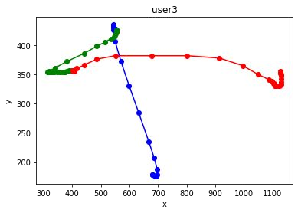

Event handling - Mouse Events (1)

<GridPane fx:controller="sample.Controller" [xmlns:fx="http://javafx.com/fxml"](http://javafx.com/fxml)

alignment="center" hgap="10" vgap="10"

|  |  |  |
| --- | --- | --- |
| **onMouseMoved** | = | "**#handleMouseMoved**" |
| **onMousePressed** | = | "**#handleMousePressed**" |
| **onMouseReleased** | = | "**#handleMouseReleased**" |
| **onMouseDragged** | = | "**#handleMouseDragged**"> |

Event handling - Mouse Events (2)

public class Controller { private PrintStream out =

new PrintStream("mouse.csv");

public void **handleMouseMoved**(MouseEvent mouseEvent){ out.println("MouseMove," +

mouseEvent.getX()+","+mouseEvent.getY());

}

}

1. **JavaFX - Programmatic UI**

public GridPane **createGridPane()**{

// ...

}

public void start(Stage primaryStage) throws Exception{ primaryStage.setTitle("Data App"); primaryStage.setScene(new Scene(**createGridPane()**)); primaryStage.show();

}

2. JavaFX - Programmatic UI (cont)

public GridPane **createGridPane()**{ GridPane gridPane = new GridPane();

//…

Button submitButton = new Button("Submit");

// …

gridPane.**add**(submitButton, 0, 3);

submitButton.setOnAction(new EventHandler<ActionEvent>() { @Override

public void handle(ActionEvent actionEvent) {

// handle the event

}

});

}

JavaFX - Event handling

User interactions →Events



Types of events

* Foreground events
  + require direct interaction of a user
  + interactions with the UI
* Background events
  + Operating system interruptions
  + Timer expiry

**Event Driven Programming**

EventDispatcher:

* receives events
* notifies interested objects

**Event**

**EventQueue**

1. ActionEvent
2. MouseEvent
3. KeyEvent

4. …..

**EventHandler**

void handle(Event event){

//…

}

**notify**

**Event Driven programming (cont)**

**Event**

**EventQueue**

1. ActionEvent
2. MouseEvent
3. KeyEvent

4. …..

1. JavaFX UI → user clicks a button (event source)
2. System creates an ActionEvent (event queue)
3. If there is any event listener/handler registered to the button → it is notified → listener/handler runs event handler method

**EventHandler**

void handle(Event event){

//…

}

**notify**

JavaFX Events

* + Event (base class)
    - InputEvent
      * Mouse Event
      * Key Event
    - WindowEvent
    - ActionEvent
    - ...

Source of Events

A component (UI control/Node) can be a source of many kinds of events.

|  |  |
| --- | --- |
| **Node** | **Event Type** |
| Button | ActionEvent |
| TextField | ActionEvent KeyEvent |
| Any kind of Node | MouseEvent |

EventHandler

JavaFX - **one interface** for all kinds of event handlers

public interface **EventHandler**<**T** extends Event>{ void **handle**(**T** event);

}

Example

ActionEvent

class ButtonHandler **implements**

**EventHandler<ActionEvent>**{ public void handle(ActionEvent evt){

//...

}

}

Example (cont)

ButtonHandler usage

* use **addEventHandler**:

button.addEventHandler(

ActionEvent.ALL, new ButtonHandler())

* use **setOnAction**:

button.setOnAction( new ButtonHandler() )

Ways to define event handlers

1. Define a class that **implements EventHandler** (*previous example*).
2. Write it as **anonymous class** (*if we need only once!*).
3. Write it as a **lambda expression** and use a reference variable to add it.
   1. **Anonymous class**

submitButton.setOnAction(new EventHandler<ActionEvent>() **{ @Override**

**public void handle(ActionEvent actionEvent) {**

**// handle the event**

**}**

**}**);

* 1. **Lambda**

submitButton.setOnAction(event-> **{**

**// statements to handle the event**

String firstname = firstnameTextField.getText(); String lastname = lastnameTextField.getText(); String email = emailTextField.getText();

out.println( new Student(firstname, lastname, email));

**}**

**}**);

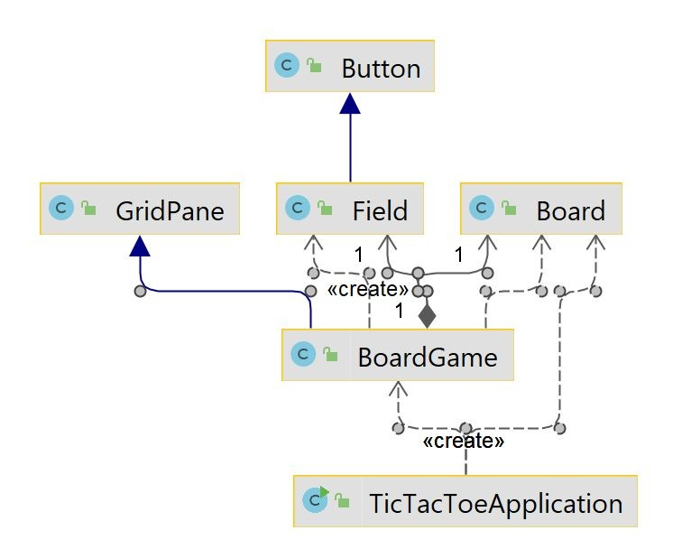

DEMO: TicTacToe

**Module 11 Collections and Generics**

Outline

* Data Structures
* Interfaces: **Collection, List, Set, Map, ...**
* Implementations: **ArrayList, HashSet, TreeMap,** ...
* Traversing collections
* Overriding **equals** and **hashCode**
* Sorting
* Problems

The Collections API

* What is?
  + Unified architecture
    - Interfaces – implementation-independence
    - Implementations – resusable data structures
    - Algorithms – reusable functionality
  + Best-known examples
    - C++ Standard Template Library (STL)
    - Smalltalk collections

The Collections API

* Benefits:
  + Reduces programming effort
  + Increases performance
    - High performance implementations of data structures
  + Fosters software reuse

The Collections API

**Design Goals**

* Small and simple
* Powerful
* Easily extensible
* Compatible with preexisting collections
* Easy to use

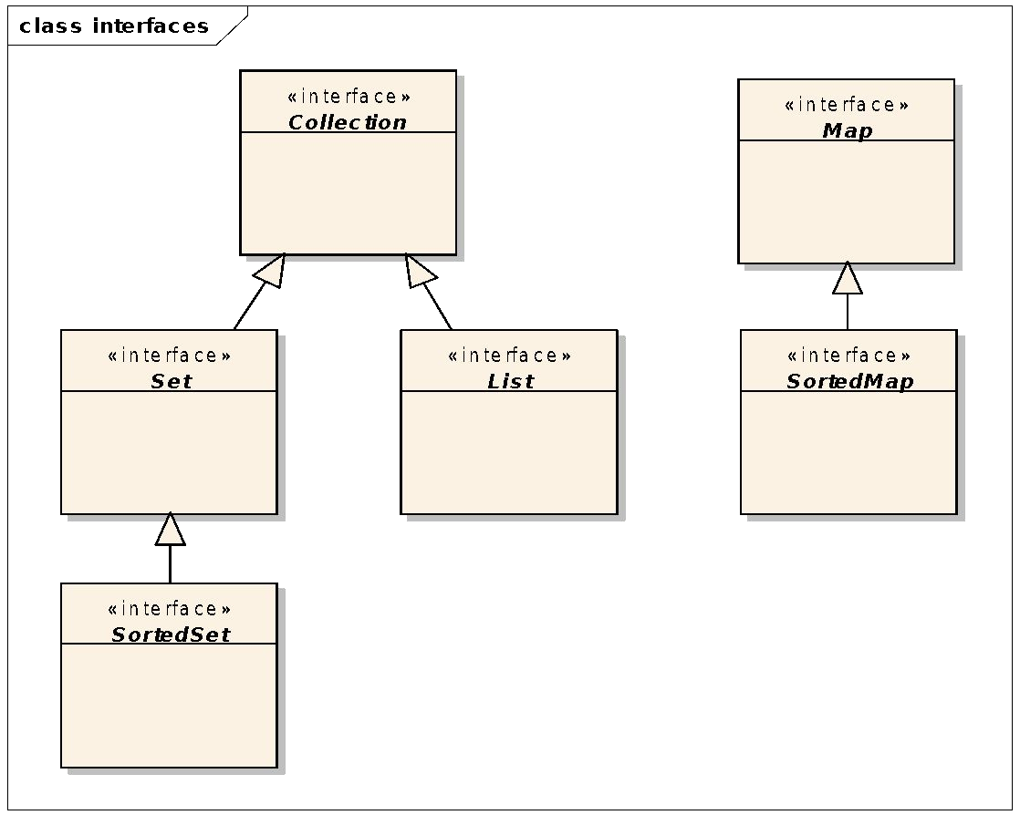The Collections API Interfaces

The Collection interface

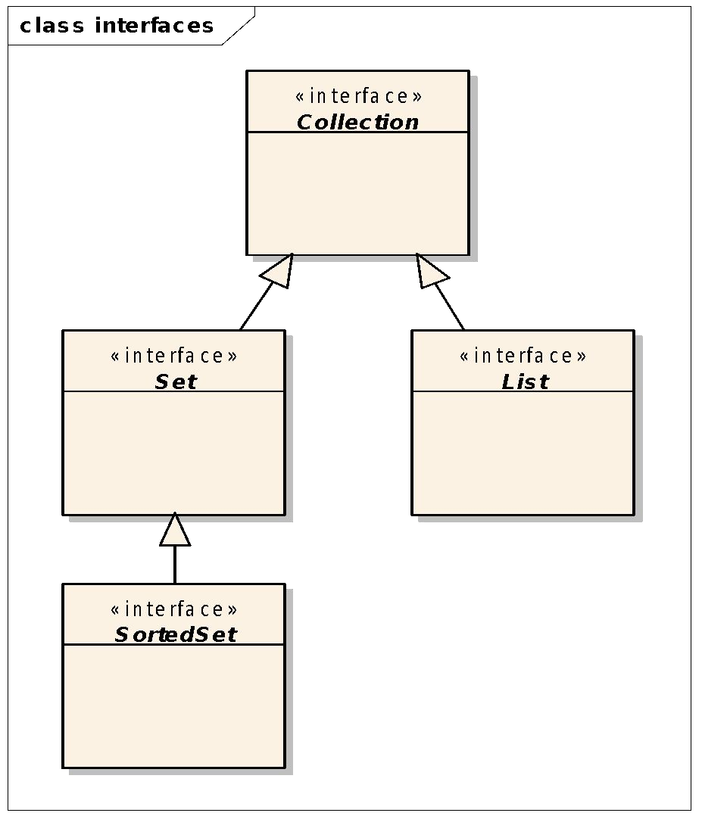

Methods:

* add(T what): boolean
* remove(T what): boolean
* size(): int
* contains(T what): boolean
* containsAll(Collection c): boolean
* equals(T what): boolean
* iterator(): **Iterator**

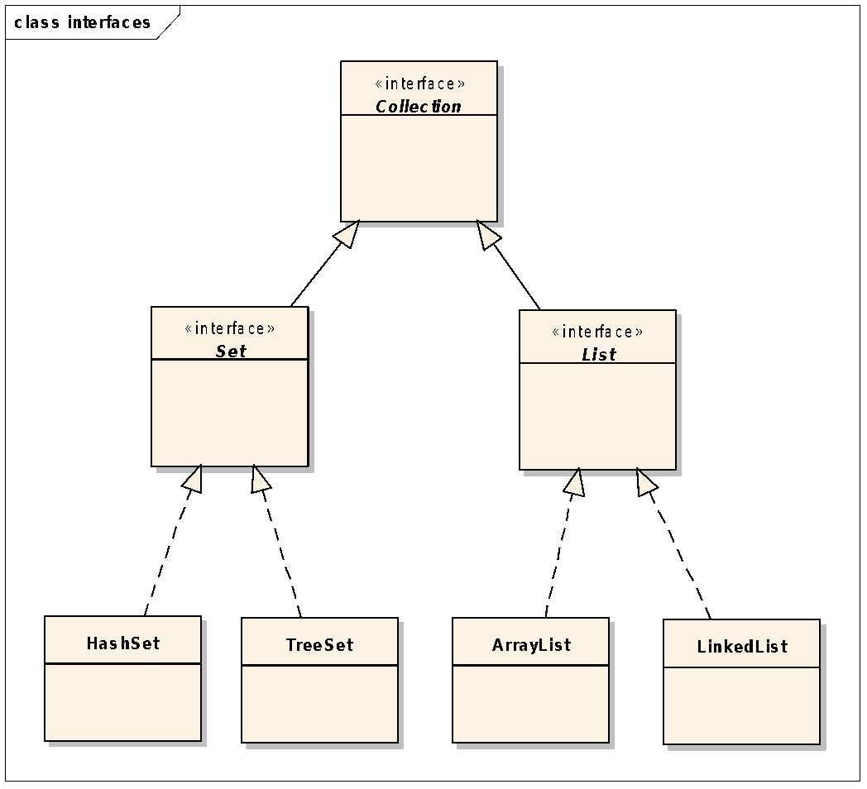

**Implementations**

Implementations

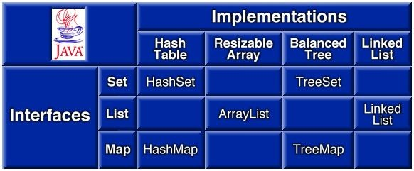

List implementations

ArrayList

|  |  |  |  |  |  |  |  |
| --- | --- | --- | --- | --- | --- | --- | --- |
| 0 | 1 | 2 | 3 | 4 |  |  |  |
|  | | | | |  | | |

size capacity

LinkedList

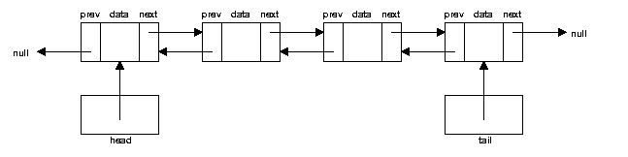

Source

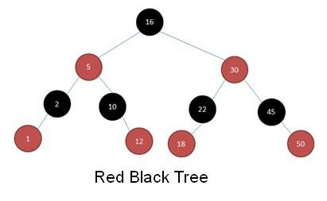Set implementations

TreeSet

Source

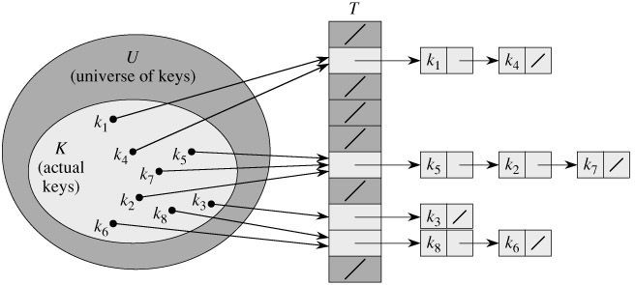HashSet

Source

Ordered vs. sorted collections

* Ordered
  + You can iterate through the collection in a specific (not random) order.
  + Each element has a previous and a next element (except the first and the last ones).
* Sorted
  + The order is determined according to some rule or rules (**sort order**).
  + Is a specific type of ordering
* Collections
* **HashSet:** unordered and unsorted
* **List:** ordered but unsorted
* **TreeSet:** ordered and sorted

Complexities

|  |  |  |  |  |
| --- | --- | --- | --- | --- |
|  | add (append) | get (position) | remove | contains |
| ArrayList | O(1) | O(1) | O(n) | O(n) |
| LinkedList | O(1) | O(n) | O(1) | O(n) |
| HashSet | O(1)* | - | O(1)* | O(1)* |
| TreeSet | O(log n) | - | O(log n) | O(log n) |

* in the case of a proper hash function

Traversing Collections

There are 3 ways:

1. for-each
2. Iterator
3. Using aggregate operations (**since Java 8**)

Traversing Collections

* 1. **for-each**

**ArrayList** list1 = new **ArrayList**();

…

for(**Object** o: list1){ System.out.println(o);

}

**ArrayList<Person>** list2 = new **ArrayList<>**();

…

for(**Person** p: list2){ System.out.println(p);

}

Traversing Collections

* 1. **Iterator**

**package java.util;**

public interface **Iterator**{ boolean hasNext(); **Object** next();

void remove(); //optional

}

public interface **Iterator<E>**{ boolean hasNext();

**E** next();

void remove(); //optional

}

Traversing Collections

**(2) Iterator**

**ArrayList** list1 = new **ArrayList**();

…

**Iterator** it1 = list1.**iterator()**; while(it1.hasNext()){

System.out.println(it1.next());

}

**ArrayList<Person>** list2 = new **ArrayList<>**();

…

**Iterator<Person>** it2 = list2.**iterator()**; while(it2.hasNext()){

System.out.println(it2.next());

}

Traversing Collections

1. **Iterator**

**ArrayList** list1 = new **ArrayList**();

**An Iterator is an object**

…

* **State:** represents a position in a collection

**Iterator** it1 = list1.**iterator()**; **●**

while(it1.hasNext()){

**Behavior:** permits to step through the collection

System.out.println(it1.next());

}

**ArrayList<Person>** list2 = new **ArrayList<>**();

…

**Iterator<Person>** it2 = list2.**iterator()**; while(it2.hasNext()){

System.out.println(it2.next());

}

Traversing Collections

1. **Using aggregate operations Java 8**

**TreeSet<String>** dict = new TreeSet<>();

Scanner scanner = new Scanner( new File("dict.txt")); while( scanner.hasNext()){

dict.add( scanner.next());

}

System.out.println("SIZE: "+dict.size()); long counter = dict.**stream()**

.**filter(** e ->

e.startsWith("the")**)**

.**count()**; System.out.println("#words: "+counter);

Problems

**Which data structure to use?**

Problem:

Split a text file into words and print the **distinct** words in

1. Increasing order (alphabetically)
2. Decreasing order

Problems

**Which data structure to use?**

Problem:

Split a text file into words and print the **distinct** words in

1. Increasing order (alphabetically)
2. Decreasing order

Solutions:

1. **TreeSet<String>**
2. **TreeSet<String> (Comparator<String>)**

Problems

**Decreasing Order**

TreeSet<String> set = new TreeSet<>();

**//...**

TreeSet<String> rev = new TreeSet<>(

new Comparator<String>()**{**

**@Override**

**public int compare(String o1, String o2) { return o2.compareTo(o1);**

**}**

**}**);

rev.addAll( set );

Problem

**Which data structure to use?**

* **Problem:** Generate 2D points having integer coordinates and print them in increasing order. Points are ordered according to their distance to the origin.

Problem

**2D Points**

public class **Point** implements **Comparable<Point>**{ public static final Point **origin** = new Point(0,0);

private final int x, y;

// constructor + getters

public String toString(){ //...}

public boolean equals(Object obj){ //...} public double distanceTo( Point point ){ //...}

**@Override**

**public int compareTo(Point o) {**

return

Double.compare(this.distanceTo(**origin**), o.distanceTo(**origin**));

**}**

}

Problem

**2D Points**

public class **Point** implements **Comparable<Point>**{ public static final Point **origin** = new Point(0,0);

TreeSet<Point> points1 = new TreeSet<>();

private final int x, y;

// constructor + getters

public String toString(){ //...}

public boolean equals(Object obj){ //...}

// **OR**

ArrayList<Point> points2 = new ArrayList<>(); Collections.sort(points2);

public double distanceTo( Point point ){ //...}

**Discussion!**

**@Override**

**public int compareTo(Point o) {**

return

Double.compare(this.distanceTo(**origin**), o.distanceTo(**origin**));

**}**

}

## Problem

Generate randomly **N = 1.000.000** (one million) **distinct** bidimensional points (x, y) having positive integer coordinates (**0 =< x <= M, 0 =< y**

**<= M, M = 1.000.000**).

**Requirements:**

Optimal solution is required.

Print the number of duplicates generated.

*Which collection to use?*

**Hint:** Finding an existing element must be fast.

Problem

* 1. solution - TreeSet

●

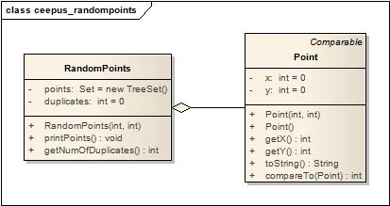

**public class Point implements**

**Comparable<Point> {**

**...**

**@Override**

**public int compareTo(Point o) { if( o == null ) throw**

**new NullPointerException(); if (this.x == o.x &&**

**this.y == o.y){ return 0;**

**}**

**if( this.x**

**return**

**==**

**o.x){**

**Integer.compare(this.y,o.y);**

**} else{**

**Integer.compare(this.x,o.x);**

**}**

**}**

**}**

## Problem

1. solution - TreeSet



**public class RandomPoints {**

**private TreeSet<Point> points =**

**new TreeSet<Point>(); private int duplicates = 0;**

**public RandomPoints( int size,**

**int interval){**

**int counter = 0;**

**Random rand = new Random(0); while( counter < size ){**

**int x =**

**Math.abs(rand.nextInt() % interval); int y =**

**Math.abs(rand.nextInt() % interval); Point p = new Point(x,y);**

**if( points.contains( p )){**

**++duplicates; continue;**

**}**

**++counter; points.add(p);**

**}**

**}**

**…**

**}**

## Problem

**TreeSet**

* Finding an element: O(log n) Implementation

Random number generator: seed = 0 N = 1.000.000

M = 10.000

Duplicates: 4976 Time: **approx. 3s**

1. solution - TreeSet

●

**public class RandomPoints {**

**private TreeSet<Point> points =**

**new TreeSet<Point>(); private int duplicates = 0;**

**public RandomPoints( int size,**

**int interval){**

**int counter = 0;**

**Random rand = new Random(0); while( counter < size ){**

**int x =**

**Math.abs(rand.nextInt() % interval); int y =**

**Math.abs(rand.nextInt() % interval); Point p = new Point(x,y);**

**if( points.contains( p )){**

**++duplicates; continue;**

**}**

**++counter; points.add(p);**

**}**

**}**

**…**

**}**

## Problem

**HashSet**

* Finding an element: O(1)

Implementation

Random number generator: seed = 0 N = 1.000.000

M = 10.000

Duplicates: 4976 Time: **approx. 1 s**

1. 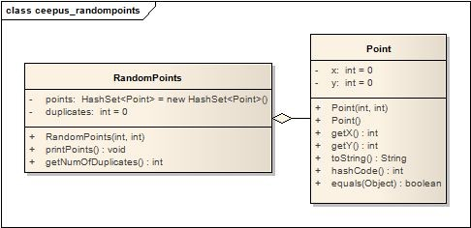solution - HashSet

●

**@Override**

**public int hashCode() { int hash = (x *31)^ y; return hash;**

**}**

**@Override**

**public boolean equals(Object obj) { if (obj == null) {**

**return false;**

**}**

**if (getClass() != obj.getClass()) { return false;**

**}**

**final Point other = (Point) obj; if (this.x != other.x) {**

**return false;**

**}**

**if (this.y != other.y) {**

**return false;**

**}**

**return true;**

**}**



●

**@Override**

**public int hashCode() { int hash = (x *31)^ y;**

**return hash;**

**}**

**@Override**

**public boolean equals(Object obj) { if (obj == null) {**

**return false;**

**}**

**if (getClass() != obj.getClass()) { return false;**

**}**

**final Point other = (Point) obj; if (this.x != other.x) {**

**return false;**

**}**

**if (this.y != other.y) {**

**return false;**

**}**

**return true;**

**}**

What happens if we don't override equals?

*How many duplicates?*

**HashSet**

* Finding an element: O(1)

Implementation

Random number generator: seed = 0 N = 1.000.000

M = 10.000

Duplicates: 4976 Time: **approx. 1s**

Problem

2. solution - HashSet

●

Problem

2. solution - HashSet



**@Override**

**public int hashCode() { int hash = 1;**

**return hash;**

**}**

**@Override**

**public boolean equals(Object obj) { if (obj == null) {**

**return false;**

**}**

**if (getClass() != obj.getClass()) { return false;**

**}**

**final Point other = (Point) obj; if (this.x != other.x) {**

**return false;**

**}**

**if (this.y != other.y) {**

**return false;**

**}**

**return true;**

**}**

What happens?

## Problem

1. solution - HashSet

The **hashCode()** contract:

●

* each time invoked on the same object must return the same value (consistent, can't be random)
* if **x.equals(y) == true**, then

**x.hashCode() == y.hashCode()** must be true

* It is legal to have the same hashcode for two distinct objects (collision)

## Problem

1. solution

Which collection to use if **M = 2000**

**Hint:** Which is the fastest access time of an element in a collection?

## Problem

3. solution

Which collection to use if **M = 2000**

**Hint:** Which is the fastest access time of an element in a collection?

**private boolean exists[ ][ ] = new boolean[ M ][ M ];**

0 1 2 3 4 5 6 7

**public RandomPoints( int size, int interval){ int counter = 0;**

**Random rand = new Random(0); while( counter < size ){**

**int x = Math.abs(rand.nextInt() % interval); int y = Math.abs(rand.nextInt() % interval); Point p = new Point(x,y);**

**if( exists[ x ][y ]){**

**++duplicates; continue;**

**}**

**++counter;**

**exists[ x ][ y ] = true;**

**}**

**}**

0

1

2

3

4

5

6

7

|  |  |  |  |  |  |  |  |
| --- | --- | --- | --- | --- | --- | --- | --- |
|  |  |  |  |  |  |  |  |
|  |  |  | T |  |  |  |  |
|  |  |  |  |  |  |  |  |
|  |  |  |  | T |  |  |  |
|  | T |  |  |  |  |  |  |
|  |  |  |  |  |  |  |  |
|  |  |  |  |  |  |  |  |
|  |  |  |  |  |  |  |  |

**[ ][ ] = new boolean[ M ][ M ];**

0 1 2

**ize, int interval){**

0

**m(0);**

1

**.nextInt() % interval);**

**.nextInt() % interval);** 2

**,y);** 3

4 T

5

Which collection to use if **M = 2000**

**Hint:** Which is the fastest access time of an element in a collection?

**private boolean exists**

**public RandomPoints( int s int counter = 0;**

**Random rand = new Rando while( counter < size ){**

**int x = Math.abs(rand int y = Math.abs(rand Point p = new Point(x if( exists[ x ][y ]){**

**++duplicates; continue;**

**}**

**++counter;**

**exists[ x ][ y ] = tr**

**}**

**}**

Problem

3. solution

|  |  |  |  |  |  |  |  |  |
| --- | --- | --- | --- | --- | --- | --- | --- | --- |
| **Bidimensional array of booleans** | | | | 3 | 4 | 5 | 6 | 7 |
| * Finding an element: O(1) | | | |
|  |  |  |  |  |
| Implementation | | | | T |  |  |  |  |
| Random number generator: seed = 0 | | | |
|  |  |  |  |  |
| N = 1.000.000 | | | |
|  | T |  |  |  |
| M = **2000** | | | |
| Duplicates: 150002 | | | |  |  |  |  |  |
| Time: **approx. 0.2 s** | | | |
|  |  |  |  |  |
|  |  |  |  |  |
| **e;** 6 |  |  |  |
|  |  |  |  |  |  |  |  |
| 7 |

**interface Map<K, V>**

* + **K** – Key type
  + **V** – Value type

*Maps keys to values.*

**Map**

**Interface**

interface **Map.Entry<K,V> (Key, Value)** pair

Examples:

**Key**: country, **Value**: capital city

* + - Slovenia → Ljubljana
    - Austria → Vienna
    - Hungary → Budapest
    - Romania → Bucharest

Map

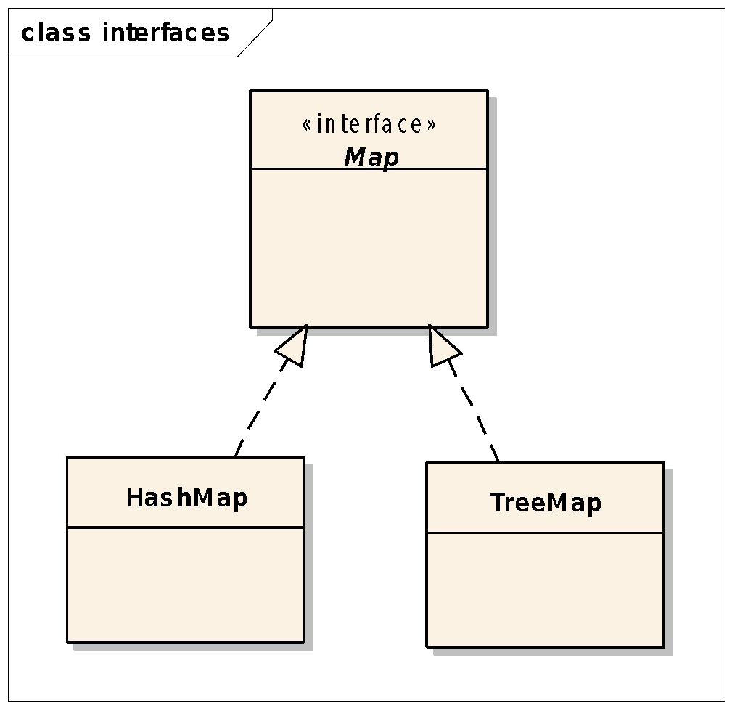**Implementations**

**HashMap:** unordered, no duplicates

**TreeMap:** ordered by key, no duplicates

|  |  |  |  |
| --- | --- | --- | --- |
|  | get | put | remove |
| TreeMap | O(log n) | O(log n) | O(log n) |
| HashMap | O(1)* | O(1)* | O(1)* |
| * in the case | of a proper | hash functi | on |

Map

**Important methods**

**Map<K, V>**

V **put**(K key, V value) V **get**(Object key)

V **remove**(Object key)

Set<K> **keySet**() Collection<V> **values**()

Set<Map.Entry<K,V>> **entrySet**()

Map

**Print entries of a map (1)**

Map<String, Counter> map = new TreeMap<>();

// fill the map

for(**Map.Entry<String, Counter>** e: map){ System.out.println(e.getKey()+”:”+e.getValue());

}

Map

**Print entries of a map (2)**

Map<String, Counter> map = new TreeMap<>();

// fill the map

for(String key: **map.keySet()**){ System.out.println(key + ”:” + map.get(key));

}

Problem

**Which data structure to use?**

Problem:

Compute the word frequencies in a text. Print the words and their frequencies:

1. alphabetically,
2. in decreasing frequency order.

Problem

**Solution (1) alphabetically**

class **MyLong** {

private long value;

public MyLong(int value) { this.value = value;} public long getValue() { return value;}

public void setValue(long value) { this.value = value;} public void **increment**() { ++value;}

}

//...

TreeMap<String, **MyLong**> frequency = new TreeMap<>();

Problem

**Solution (2) decreasing frequency order**

class **Pair** {

private String word; private long fr;

// constructor + get and set methods

}

ArrayList<Pair> list = new ArrayList<Pair>(); for (String key : frequency.keySet()) {

long value = frequency.get(key).getValue(); list.add(new Pair(key, value));

}

Collections.sort(list, new **Comparator<Pair>() { @Override**

**public int compare(Pair o1, Pair o2) {**

**return Integer.compare(o2.getFr(), o1.getFr());**

**}**

**}**);

Problem:

Problem

**Which data structure to use?**

Find the anagrams in a text file!

Problem

**Which data structure to use?**

Problem:

Find the anagrams in a text file!

**Solution:**

* Split the text into words
* Alphabetize the word
  + sent → enst
  + nest → enst
  + tens → enst
* Map<String, List<String> > vs. Map<String, Set<String> >
  + Key: alphabetized word → String
  + Value: words → List<String> or Set<String>

Problem

**Anagrams**

**Map<String, Set<String> > groups** = new HashMap<>();

//...

String word = cleanWord(word); String **key** = alphabetize(word);

// Find the **key**

Set<String> **group** = groups.get( **key**); if (**group** == null) {

Set<String> **newGroup** = new HashSet<String>();

**newGroup**.add(word); groups.put( **key**, **newGroup**);

} else{

**group**.add(word);

}

Problem

**Anagrams**

**Map<String, Set<String> > groups** = new HashMap<>();

//...

private void printGroups(int size) {

**for (String key : groups.keySet()) { Collection<String> group = groups.get(key);** if (group.size() == size) { System.out.print("Key: " + key + " --> ");

**for (String word : group) {**

System.out.print(word + " ");

**}**

System.out.println();

}

**}**

}

# Module 12 Serialization

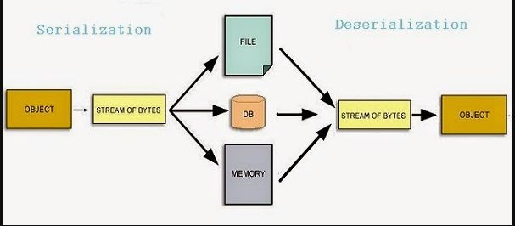

https://krishankantsinghal.medium.com/serialization-and-deserialization-5046c958c317

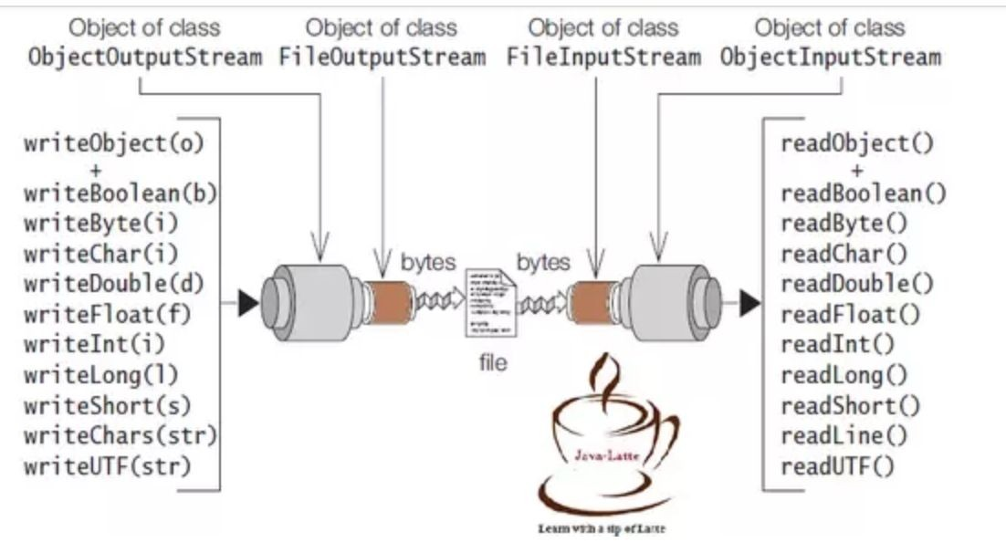

https://krishankantsinghal.medium.com/serialization-and-deserialization-5046c958c317

Rules

* 1. If a **parent class** has implemented Serializable interface then child class doesn’t need to implement it but vice-versa is not true.
  2. Only **non-static data members** are saved via Serialization process.
  3. **Static data members and transient data** members are not saved via Serialization process.So, if you don’t want to save value of a non-static data member then make it transient.
  4. **Constructor of object** is never called when an object is deserialized.
  5. **Associated objects** must be implementing Serializable interface.

SerialVersionUID

1. Declared explicitly in the class
2. Calculated by the serialization runtime

Example

public class Student implements **Serializable**{ private final String firstname;

private final String lastname; private **transient** String password;

// ...

}

Example (cont)

Student student1 = new Student("John", "Black");

// save the object to file

try (**ObjectOutputStream** out = new ObjectOutputStream( new FileOutputStream("student.ser"))){

out.**writeObject**(student1);

} catch (Exception e) { e.printStackTrace();

}

// read the object from file

try(**ObjectInputStream** in = new ObjectInputStream( new FileInputStream("student.ser"))){

student1 = (Student) in. **readObject**(); System. *out*.println(student1); System. *out*.println("Counter: " +

Student. *getCounter*());

} catch (Exception e) { e.printStackTrace();

}